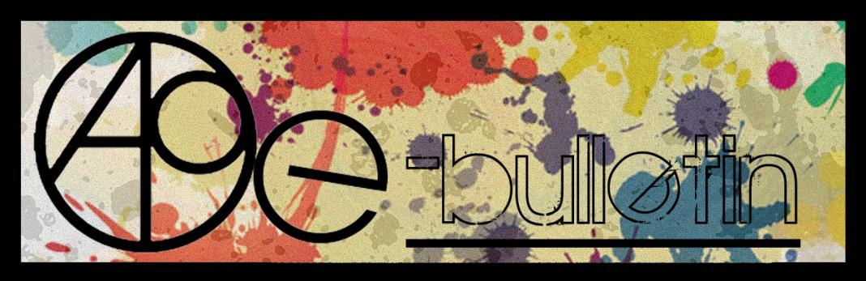

**Kilkenny County Council Arts Office E-bulletin 15th July 2016**

Dear All,   
  
Welcome to the fortnightly e-bulletin from Kilkenny County Council's Arts Office. Each bulletin is packed with the latest information on Kilkenny Arts Office activities, county events as well as news and opportunities for arts practitioners from around the country.

This service will be provided fortnightly. To include an item in the next e-bulletin please send a brief outline of your advert with relevant contact details, including any websites or pages with links to [**niamh.brophy@kilkennycoco.ie**](mailto:niamh.brophy@kilkennycoco.ie) **before 27th July.** The next e-bulletin will be on the **29th July.**

While every effort has been made to ensure the accuracy of our information, we strongly advise readers to verify all details to their own satisfaction.

Regards,

**Niamh Brophy, Arts Administrator**

Arts Office LogoWithText01

5 Dean Street, Kilkenny

T: (056) 7794138

E: [niamh.brophy@kilkennycoco.ie](niamh.brophy@kilkennycoco.ie%20)

W: <www.kilkennycoco.ie/eng/Services/Arts>

[Facebook](https://www.facebook.com/KilkennyArtsOffice/) [twitter](https://twitter.com/kkartsoffice)

[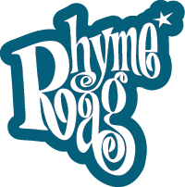](http://www.rhymerag.net/) [Facebook](https://www.facebook.com/KilkennyArtsOffice/) 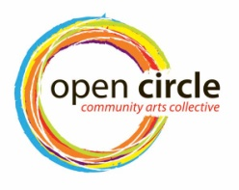 [Facebook](https://www.facebook.com/KilkennyArtsOffice/) [twitter](https://twitter.com/kkartsoffice) [](http://www.artlinks.ie/) [Facebook](https://www.facebook.com/KilkennyArtsOffice/)

<www.rhymerag.net> <https://opencirclearts.ie/> [www.artlinks.ie](http://www.artlinks.ie)

**Kilkenny County Council Cultural Services -**

**Creating and Sustaining Great Communities and Places**

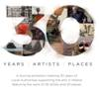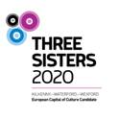 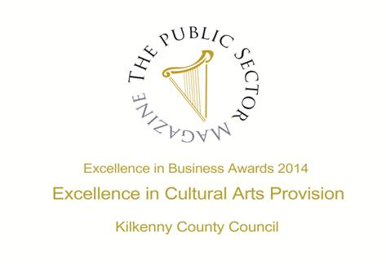

**Arts Office**

* **NEW! Arts Office receives a facelift**
* **NEW!** ‘Unfold’ an exhibition by Open Circle Arts
* **NEW! The SEWCIALISING has begun!**

**Kilkenny Events**

* **NEW!** BarnFest
* **NEW!** Revelation exhibition at St. Luke’s Hospital, Kilkenny
* **NEW!** Project Migrants at Loughboy Library
* **NEW!** Ceramics Ireland Festival 2016
* **NEW!** Kilkenny Arts Festival Box Office
* **NEW!** Volunteer with the Kilkenny Arts Festival
* **NEW!** Jane O’Malley Exhibition at Joan Clancy Gallery, Dungarvan
* **NEW!** YuleFest
* **NEW!** KCAT Dance Course 2016/2017
* Blackstack Studio Manager Position
* Alternative Arts Kilkenny
* KCAT enrolling for 2016 / 2017
* Devious Theatre’s ‘The Hellfire Squad’
* WHAT welcomes its 2016 Artist in Residence to University Hospital Waterford

# **Mandala Workshop with Alice Bennett at Blackwatch Studio**

* Call For Participants’: Kilkenny Libraries Poetry Reading Event October 2016
* Ballykeeffe Amphitheatre: Declan O’Rourke
* Outdoor Cinema at Kilkenny Castle
* National Craft Gallery News

**Courses / Training / Jobs / Internships**

* **NEW!** Children’s Exhibition Curator Wanted for Dun Laoghaire-Rathdown County Council
* **NEW!** CIT Crawford College of Art and Design: Special Purpose Award, Level 8 Certificate

### ****NEW!** Novel Fair 2017**

### NEW! SAVE THE DATE: 26 August | VAI Get Together 2016

* [Physical Theatre & Mask Technique Master Class with Boom Circus (US)](http://www.isacs.ie/physical-theatre-and-mask-technique-master-class-with-boom-circus-us/)
* **Adult Continuing Education in European Art History at UCC, Cork**
* NYCI Certificate in Youth Arts 2016/2017

**Call for Submissions / Residencies / Public Art**

## NEW! Irish Writers’ Centre Listing of Call for Submissions for Competitions

* **NEW!** *Metro Éireann* – Call for Submissions
* **NEW!** Curious Minds | Youth Arts Commission Call Outs
* **NEW!** Open Call | RUA RED Art Prize and Winter Open 2016 | (*Submission Fee)

## NEW! Doire Press – open for submissions

* **NEW! Open Call | Droichead Arts Centre Exhibition Programme 2017**
* **NEW! The United Nations / Ranan Lurie Political Cartoon Awards 2016**

## NEW! Open Call for a Socially Engaged Commission at Tate Liverpool as part of the Collaborative Arts Partnership Programme funded by Creative Europe

* **NEW!** Open Call to Members | 126 Exhibition Programme 2017
* **NEW!** 8 Weeks Left to Enter the Aesthetica Art Prize 2016: Prizes Include Exhibition & £5,000
* **NEW!** Call for 3 Minute Film Challenge Submissions, Wexford Documentary Film Festival
* **NEW! Associate Artist 2016-17: Dance Ireland Open Call**
* RTÉ’s new TV programme Painting The Nation – Call for Applications
* **Fingal County Council Graduate Award 2016 in Partnership with Block T**
* **D.I.V.A. Collaborative Art Project at Electric Picnic 2016**
* **Open Call for Exhibitions and Studios Membership | Custom House Studios 2017/18**
* **Open Call for Emerging Artists | BLOOOM Awards 2016, Germany**
* **Accepting Applications for VAI / DAS Residency Award 2016**
* **Open Call for Exhibition Programme 2017, The Séamus Ennis Arts Centre, Co. Dublin**
* **The Sean O Faolain International Short Story Award**
* **Per Cent for Art Commission | St. Raphael’s College, Loughrea, Co. Galway**
* 2016 Over The Edge New Writer of The Year competition
* Open Call | OpenART Biennial 2017, Sweden
* Hennessy Portrait Prize 2016 l National Gallery of Ireland

**Awards / Bursaries / Schemes**

* **NEW!** Jack Harte Bursary 2017
* **NEW! Arts Council of Ireland Funding**
* **NEW!** Arts Council Northern Ireland | Rosy James Memorial Trust Award
* **NEW!** Grants and Funding from the Department of Arts, Heritage, Regional, Rural and Gaeltacht Affairs

**Of Interest**

* **NEW!** What Next? | Weekly meeting next Wednesday 29 June, 8.30am
* **NEW!** The Department formerly known as Regional Development, Rural Affairs, Arts and the Gaeltacht to be renamed Department of Arts, Heritage, Regional, Rural and Gaeltacht Affairs

**Arts Office**

**NEW! Arts Office receives a facelift**

**Check out the new signage on our building at 5 Dean Street.**

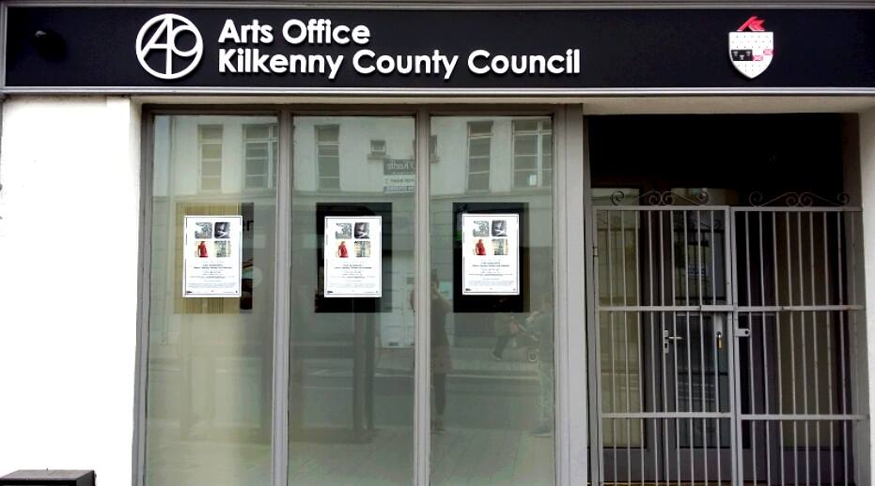

**______________________________________________________________________________________**

**NEW! The SEWCIALISING has begun!**

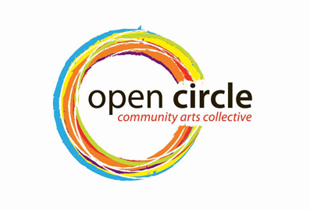

The first of our workshops in mending preloved denim, using the Japanese Boro technique of Sashiko embroidery took place.

Lots of beautiful work created this week!

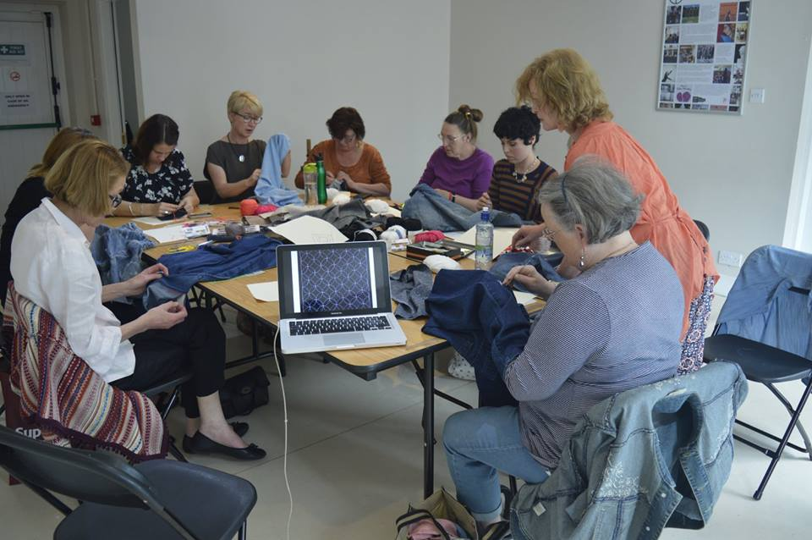 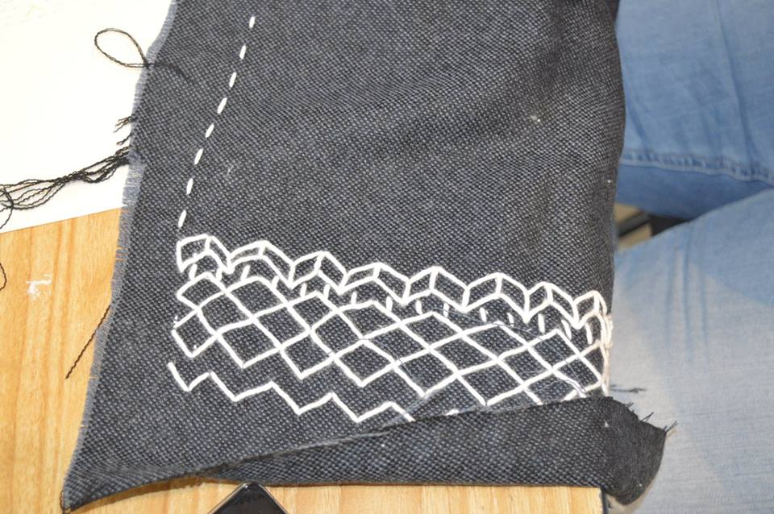

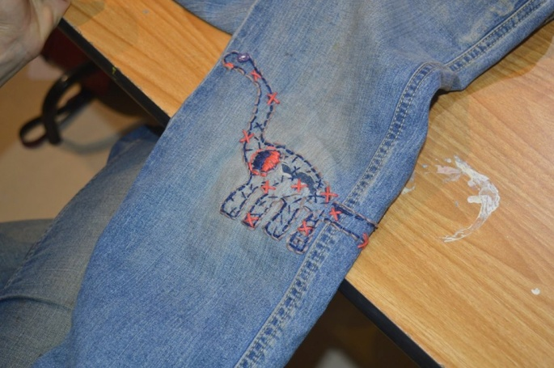 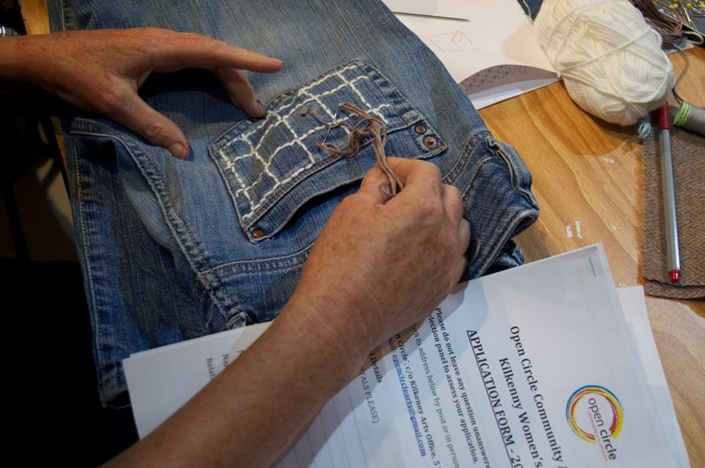

Looking forward to the next few weeks when we will be learning to darn wool and much more....

**For more information and booking:** [**sewcialisingproject@gmail.com**](mailto:sewcialisingproject@gmail.com)

Please see the Open Circle Arts website [**www.opencirclearts.ie**](http://www.opencirclearts.ie) for further information on this and other programs. Visit and Like our Facebook pages Open Circle Arts / Kilkenny Arts Office

Open Circle Arts is a Kilkenny Arts Office programme. The Arts Office acknowledges the support of the Arts Council, Carlow Kilkenny ETB and Kilkenny County Council’s Waste Prevention Programme.

**______________________________________________________________________________________**

**NEW! ‘Unfold’ an exhibition by Open Circle Arts**

**Free event**

**Launch 6th August 12pm   |   Open Circle House, High Hayes, Johns Green, Kilkenny**

**Open hours – 12pm – 5pm, 6th – 14th August**

Open Circle Arts is a community arts project providing social spaces for learning and creating. Our mission is to inspire interest and maximum participation in the arts for Kilkenny women. We are committed to offering programs that are characterised by quality Kilkenny women. We are committed to offering programs that are characterised by quality arts learning experiences and inspiring arts participatory engagements. arts learning experiences and inspiring arts participatory engagements.

[www.opencirclearts.ie](http://www.opencirclearts.ie)

**Kilkenny Events**

**NEW! BARNFEST**

**Barnstorm Theatre Company celebrates its 25th year with a season of plays for children and their families.**

********************************************

From Scotland, **Shona Reppe** presents:

**The Curious Scrapbook of Josephine Bean**



Who was Josephine Bean? The wonderful and surprising secret is revealed with each turn of the page…

Join the world renowned scrapologist, Patricia Barker, as she discovers the secrets held within the pages of a scrapbook. Everything is flat, pressed, squished. A dusty, musty smell mixes with the scent of old lavender and slowly, page-by-page, the scrapbook becomes a window into a secret world and a curious life unfolds before us.

**Ages 7+**

*‘a highly original, beautifully delicate and thoroughly engaging piece of children’s theatre’*

(Sunday Herald)

*‘A truly wonderful show that will charm parents as much as their children’*

(The Stage)

*‘part-detective story, part-journey into the imagination’*

(Mark Fisher)

Winner: Theatre Awards UK, best production for children and young people.

**When:** Saturday 6th August at 12pm and 3pm

Sunday 7th August at 12pm and 3pm

**Where:** The Barn, Church Lane (behind St Canice’s Cathedral)  
  
**Tickets:** €8.00 / Family of 4: €30

**Bookings:** kilkennyarts.ie or 056 775 2175

********************************************

From Belfast, **Young at Art** presents:

**Once Upon A Time**

A unique interactive performance where children actively take part in the creation and telling of a new story under the guidance of the Story Tellers.

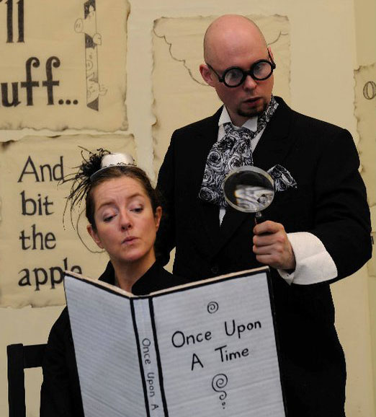

The very trusted and nearly excellent Guardians of Tall Tales and Small Stories look after EVERY STORY EVER MADE IN THE WORLD in the most Extraordinary Wonderful and Magical Library.

BUT there was a fire and the stories were destroyed!

The very trusted and nearly excellent Guardians of Tall Tales and Small Stories have to find EVERY story again and have found all of them……EXCEPT FOR ONE!!

Can you help them find the very last missing story?

However, there is a twist… one of the storytellers cannot speak, but he can draw. The story that the children create unfolds before their very eyes, drawn onto a large drawing board.

**Ages 5+**

*“One of the most delightful kids shows I have ever been a part of”* (Audience member)

**When:** Wednesday 10th August at 10.30am & 12.30pm

Thursday 11th August at 12.30pm & 3pm

**Where:** The Barn, Church Lane (behind St Canice’s Cathedral)

**And also at a second venue…**

**When:** Wednesday 10th August at 3pm

Thursday 11th August at 10.30am

**Where:** Rothe House, Parliament Street  
  
**Tickets:**  €8.00 / Family of 4: €30

**Bookings:** kilkennyarts.ie or 056 775 2175

********************************************

From Belfast,**Cahoots NI** presents:

**Shh! We Have a Plan**

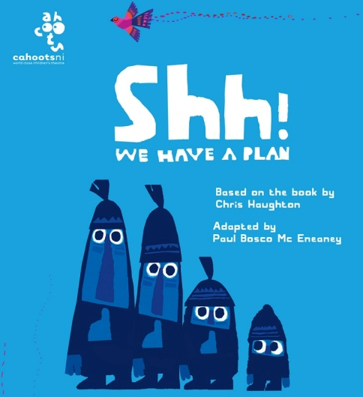

A new & exciting theatrical adventure for young children!

Shh! We have a Plan is the brand new theatre production by the multi award winning Theatre Company Cahoots NI. Based on the Chris Haughton book of the same title, this delightful and poignant tale follows the journey of some madcap characters each of whom has a plan, they all want to capture a beautiful bird perched high in a tree! Sounds simple, but the quest becomes an obsession and the obsession becomes the absurd! Where will it all end? Join us as we follow the characters’ exploits, meet an elusive and magical little birdie and discover that perhaps freedom and kindness are more important than getting what you want at any cost!

Prepare to be enchanted and amazed by this unique and engaging production featuring Magic, Music, Puppetry and lots lots more!"

**Ages 4+**

Created and Directed by Paul Bosco Mc Eneaney

Music by Garth Mc Conaghie

**When:** Saturday 13th August at 12pm and 3pm

Sunday 14th August at 12pm and 3pm

**Where:** The Barn, Church Lane (behind St Canice’s Cathedral)  
  
**Tickets:** €8.00 / Family of 4: €30

**Bookings:** kilkennyarts.ie or 056 775 2175

For all bookings and information on any of the above, please contact Kilkenny Arts Festival at kilkennyarts.ie or phone 056 775 2175

**_______________________________________________________________________________________**

**NEW! Revelation exhibition at St. Luke’s Hospital, Kilkenny**

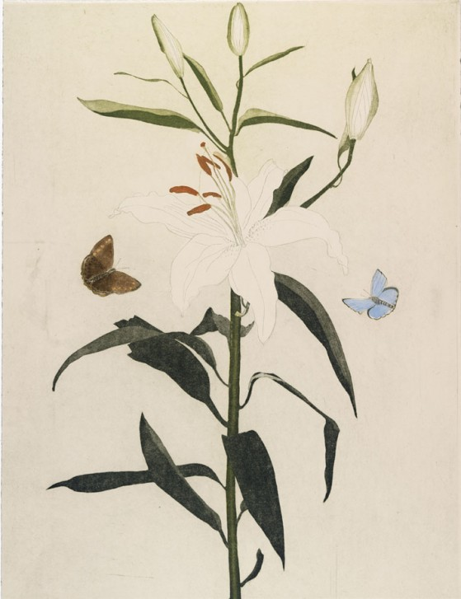

Image shown: Section of Lillies by Cliona Doyle, Etching, 65 x 50 cm, Commissioned by National Gallery of Ireland, 2008

*Revelation* is a limited edition of twenty nine specially commissioned prints created by members of Graphic Studio Dublin and invited artists on long-term display in the new Oncology Ward of St. Luke’s General Hospital Carlow/Kilkenny. The prints are from a collaboration between the National Gallery of Ireland & Graphic Studio Dublin and the collection is on long term loan by Dr. Abdul Bulbulia to the hospital. The exhibition will launch at 4.00pm on Thursday 21 July 2016, in the Oncology Day Ward at St. Luke’s General Hospital, Kilkenny (SLGHK).

This important collection was first shown at an exhibition in the National Gallery of Ireland which ran from April to September 2008. The concept for the exhibition dates back to 2005 when Graphic Studio Dublin (GSD) approached the National Gallery of Ireland with an idea for an exhibition of prints. *Revelation* was chosen as the theme for the show. In dealing with the profound concept of revelation –*‘to make known something hidden’* – many of the artists and printmakers chose to embrace religious concepts of revelation, whilst others focused on the philosophical, scientific or secular dimensions of the topic. For many of the participating artists, the Gallery’s collection has been the source of inspiration for their creations.

Of the twenty nine artists involved, eighteen are printmakers who devised and executed the work themselves. Expert printmakers from GSD, Robert Russell and Tom Phelan, assisted non-print artists to translate their ideas into print form. The prints in the show feature a variety of techniques from mezzotint to carborundum, and from etching to collography.

Anne Hodge, curator of *Revelation*, and Prints and Drawings at the National Gallery of Ireland will launch the exhibition and says that the response to the idea has been wonderful: *“Part of my job was to facilitate artists by providing access to the Gallery’s collection. Some artists found this helpful while others preferred to spend time with the paintings without outside interpretation or explanation.”*

Among the artists featured in the exhibition are: Pamela Leonard, Cliona Doyle, Brian Lalor, Yoko Akino, Stephen Lawlor, Robert Russell, Clare Henderson, Tim Goulding, Jean Bardon, Tom Phelan, Lina Nordenström, Terence Gravett, Yoko Hara, Nickie Hayden, Sharon Lee, Maev Leneghan, Siobhan Hyde, Kelvin Mann, William Crozier HRHA, Guggi, John Kindness, Carmel Benson, Mary Lohan, Maeve McCarthy RHA, Martin Gale RHA, Donald Teskey, Seán McSweeney HRHA, Nigel Rolfe and Marta Wakula-Mac.

Mark Patrick Hederman who opened the exhibition at the National Gallery of Ireland said; “*Art as Revelation is a truth which has not been seen before which is only reaching towards some delineation, edging its way forward in search of form. Such art not only heralds a ‘brave new world’, it helps to create such a world.”*

*“We are delighted to have been chosen as the location for the display of such an acclaimed collection of art,”* said Anne Slattery, General Manager, St. Luke’s General Hospital Carlow-Kilkenny. *“The patients and staff using the Oncology Day Ward will benefit greatly from this exhibition. We are grateful to the donor for his foresight in identifying the Oncology Unit as a location for this collection, which will enhance the patient experience.”*

Edelle Nolan the Arts Officer explains that, *“Ambulatory oncology care at SLGHK, is the first of its kind in Ireland, it is set up as a new model of care, and is entirely a day service oncology ward, the ethos being, that patients can get swift treatment, and spend as little time as possible in hospital during their cancer treatment. This is in line with current best practice, as the patient would have less exposure to hospital borne illnesses and also they would feel less like a patient needing hospital treatment and spend quality time at home with their families. Also with no need for overnight accommodation for ongoing oncology care, the savings gained can be spent on treating the patients, rather than providing accommodation, especially as patients, prefer to stay at home as much as possible, where there is less disruption to daily life for families & friends. While the patient is in hospital, we seek to create a pleasant environment using these beautiful fine art limited edition prints, in the treatment bays and in the corridor or the Oncology Ward. We are very grateful and fortunate to have received this wonderful long term donation.”*

For more information about the arts programme at SLGHK contact Edelle Nolan on [edelle.nolan@hse.ie](mailto:edelle.nolan@hse.ie)

**_______________________________________________________________________________________**

**NEW! Project Migrants at Loughboy Library**

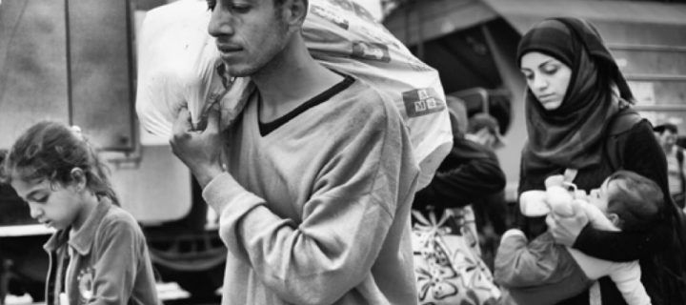 [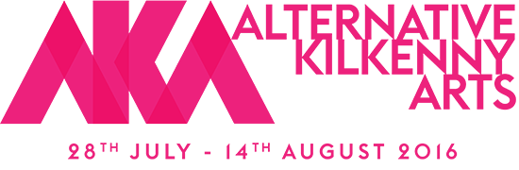](http://akafringe.com/)

  PROJECT MIGRANTS

**Loughboy Library 28th July-14th August 2016**

A Photographic Study of the Migrant and Refugee Crisis from the Greek / Macedonia border 2015.  
By Luigi Ottani (Modena, Italy)

Supported by Kilkenny Library Services, Kilkenny County Council, Municipality of Formigine, Italy and Kilkenny Integration Forum.

**_______________________________________________________________________________________**

**NEW! Ceramics Ireland Festival 2016**

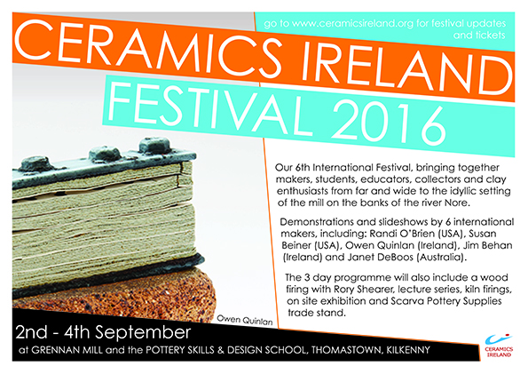

**_______________________________________________________________________________________**

**NEW! Kilkenny Arts Festival Box Office**

Our Festival Box Office is now OPEN. We're at 16 John Street and if you hurry on down you might even get some cake. See [www.kilkennyarts.ie](http://www.kilkennyarts.ie)

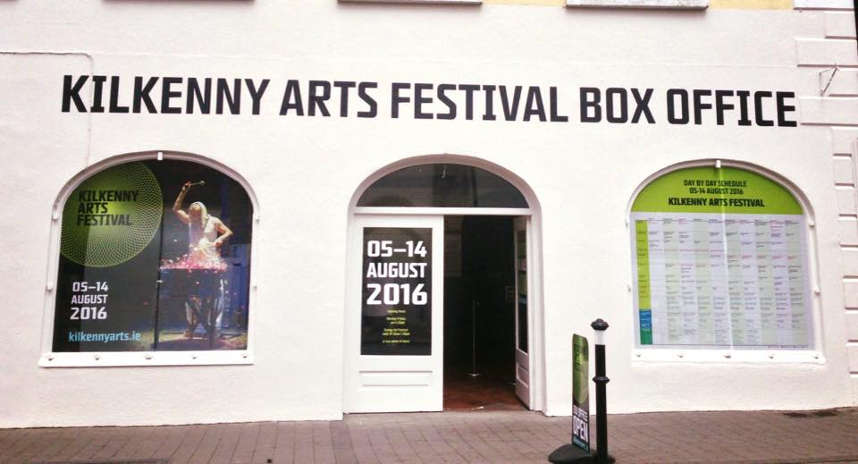

**_______________________________________________________________________________________**

**NEW! Volunteer with the Kilkenny Arts Festival**

See [www.kilkennyarts.ie](http://www.kilkennyarts.ie)

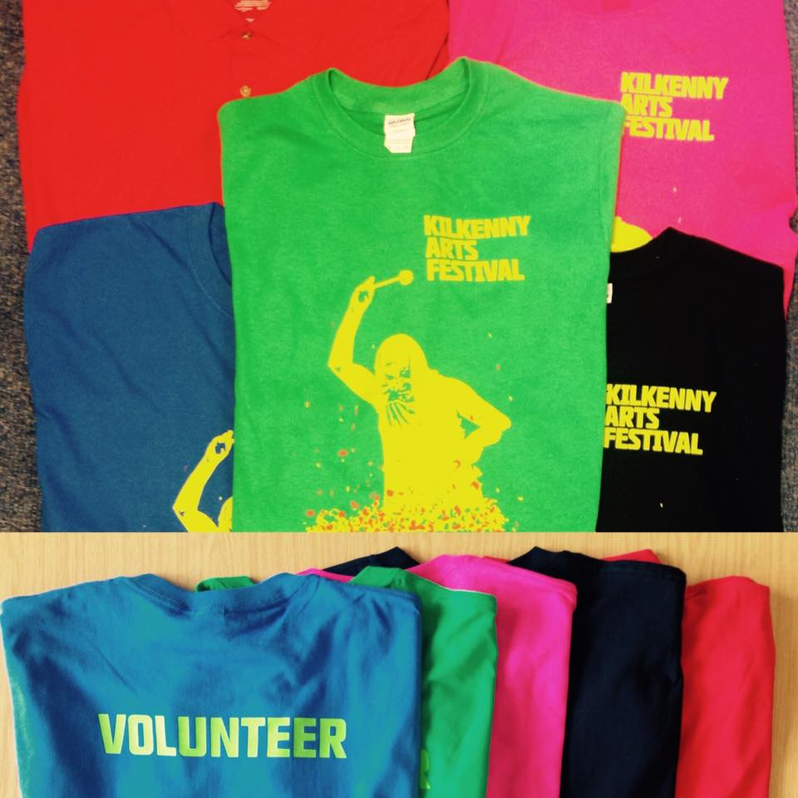

**_______________________________________________________________________________________**

**NEW! Jane O’Malley Exhibition at Joan Clancy Gallery, Dungarvan**

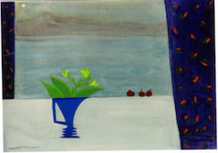

9 to 23 July

Pure line and colour are the central components of Jane O’Malley’s work. The design of her jugs, flowers and vases are often set against a window reflecting their surroundings.

The Joan Clancy Gallery is uniquely situated overlooking the sea, located near Colaiste na Rinne and the Cunnigar Beach in the Waterford Gaeltacht.

Joan Clancy Gallery, Mweelahorna, Ring, Dungarvan.  
T: 086 813 4597  
E: [**info@joanclancygallery.com**](mailto:info@joanclancygallery.com)  
W: [**joanclancygallery.com**](http://www.joanclancygallery.com/)

**_______________________________________________________________________________________**

**NEW! YuleFest**

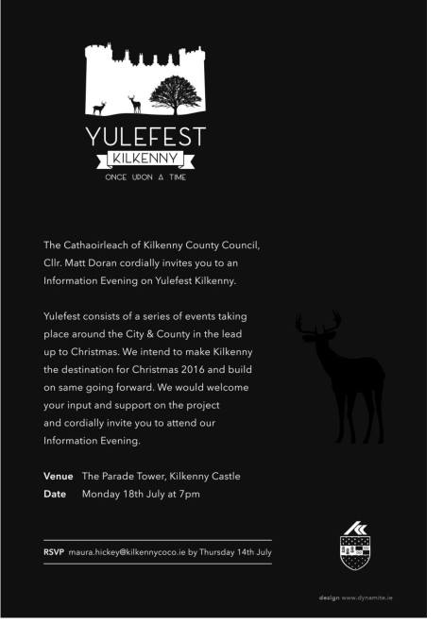

**_______________________________________________________________________________________**

**NEW! KCAT Dance Course 2016/2017**

This unique course gives a practical foundation to current dance models taught by a range of practicing dance artists and performers. Inclusive teaching methods accommodate enthusiastic beginners and those who wish to revisit and develop dance.

Emphasis is placed on individual and groups work, creating dances and developing performance skills. It touches on a variety of dance techniques, for example Dance improvisation, Contact Improvisation (CI) Somatic practices, Laban technique and release technique. An opportunity is also given for individual guidance and mentoring. Past teachers have included, Cindy Cummings, Susie Lamb, Lisa Cahill, Deirdre Grant.

See [www.kcat.ie](http://www.kcat.ie/) or contact Alice at KCAT Art and Study Centre, alice@kcat.ie or phone 0567755115 for more information.

**_______________________________________________________________________________________**

**Blackstack Studio Manager Position**



Blackstack Studio, situated in the heart of Kilkenny city, aims to promote the art of printmaking and support artists by providing intaglio and screen print facilities in the southeast. Part of a growing network of green studios worldwide, we use environmentally sustainable printmaking methods. We also provide outreach and education programmes such as workshops, lectures and demonstrations bringing the art of printmaking into the heart of the community.

Blackstack Studio is now looking to appoint a confident and self-motivated person to become our Studio Manager. The successful individual will be responsible for managing the day to day running of Blackstack Studio, reporting directly to the Board via weekly updates and regular meetings. An ability to work independently, excellent administration and organisation skills and creative thinking are essential in this role and applicants must also be able to demonstrate the following:

* Experience in the visual arts, preferably in an arts administration role or work within an arts organisation
* Developing new opportunities, projects and initiatives for Blackstack Studio in conjunction with the Board
* Experience in dealing with funding applications
* Ability to find and create opportunities to promote Blackstack Studio via its website, press releases and on social media, and where applicable to provide press releases and other related content
* Ability to engage with individuals and groups to foster new links, collaborations and exchanges
* Excellent spoken and written communication skills

Knowledge of print and print processes is preferred but not essential.

This is a 12 month contract, 6 hours/week minimum although the successful applicant will be expected to work longer hours at busy periods as necessary. The applicant will be based in Kilkenny Arts Office and Blackstack Studio. All applicants must have their own transport and a full driving licence. In return we offer an excellent remuneration, based on experience, together with a phone allowance and laptop.

To apply:

Application is by email **only**. Please send CV and covering letter to dawn@blackstackstudio.com

Deadline for applications is 5pm on Friday 22 July, 2016.

All successful applicants will be required to interview at Blackstack Studio in Kilkenny.

**_______________________________________________________________________________________**

**Alternative Arts Kilkenny**

[](http://akafringe.com/)

Alternative Kilkenny Arts (AKA) is a collaboration of people living in Kilkenny who have an interest in or practice within the arts around the City and County. Alternative Kilkenny Arts Fringe Festival provides a great opportunity for many not involved in the main programme to exhibit, perform, recite and activate their work around the City during the Festival. There has from time to time been a tradition of an informal fringe programme to compliment the main festival. But it has been inconsistent. AKA is endeavouring to bring together these strands under a single programme to promote a diverse range of artistic and creative talent, offer a platform and to raise awareness to patrons of the festival that all of this is going on in our City; all of the time!

In the limited time and within the limited resources we had to put this together, we regret that much of the visual arts strand and many other events are not listed here. It would simply be impossible to cover it all.  It is our hope that in exploring our lovely little City that you will wander in to many of the wonderful exhibitions that cram every available wall space in the City and even on our Mayor’s Walk.

We are most grateful to all who have given of their time, shared their skills and donated hard cash to bring this programme together. A big thanks to Karol Ryan for his graphic design work and to all the artists, musicians, creators, practitioners and misfits who make Kilkenny such a unique melting pot of creativity. Most of all we hope that you will go out and shop local and buy and support Alternative Kilkenny Arts! Enjoy the Festival!

There is no committee as such, but these people helped putting stuff together for what we hope will be the first of many AKA’S. It’s open to everyone and very inclusive so get involved! Willie Meighan, Malcolm Noonan, Karol Ryan, Nicci St George Smith, Arthur Drohan, Niamh Moroney, Cathal McFarlane, Ciaran O Neill, Johnny Keenan, Ann Mulrooney, Mary Butler, Dermot Agnew…

<http://akafringe.com/>

**_______________________________________________________________________________________**

**KCAT Courses 2016 - 17**

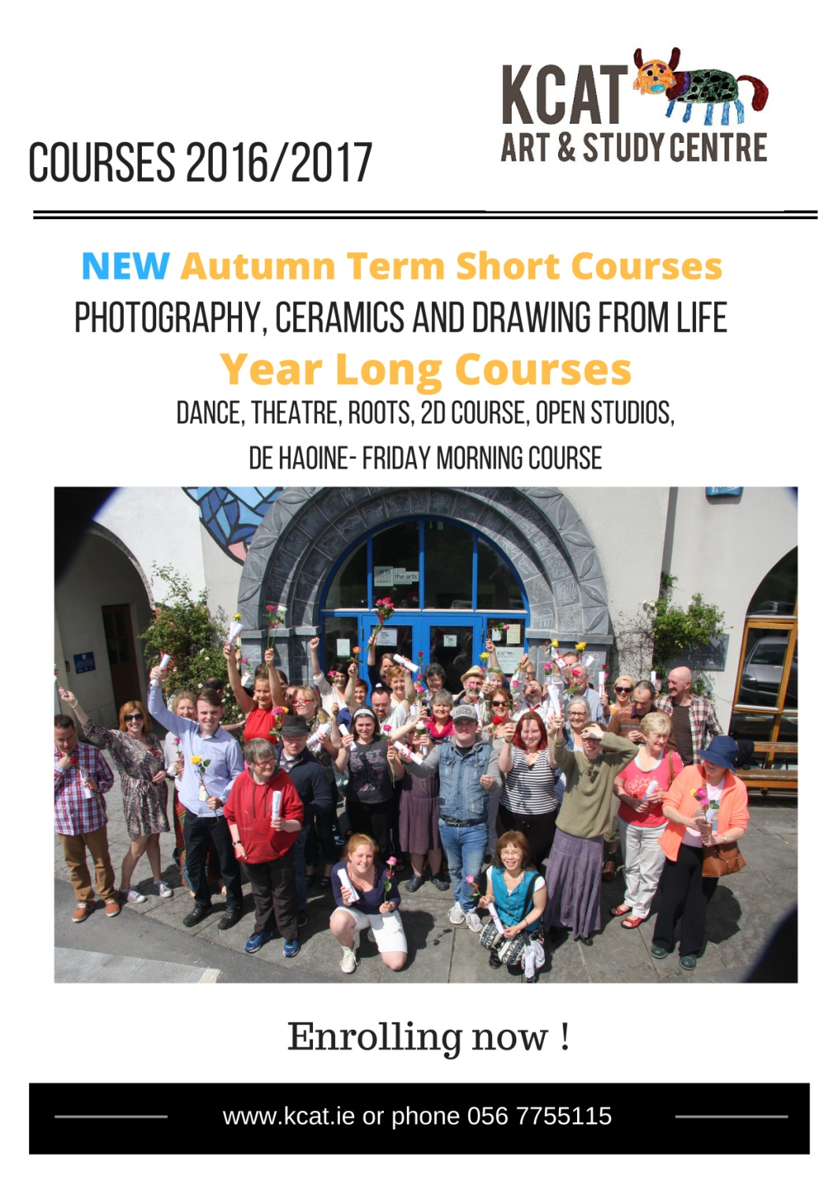

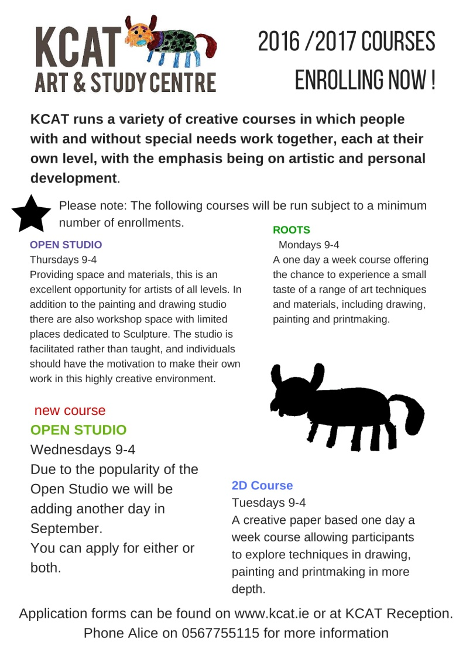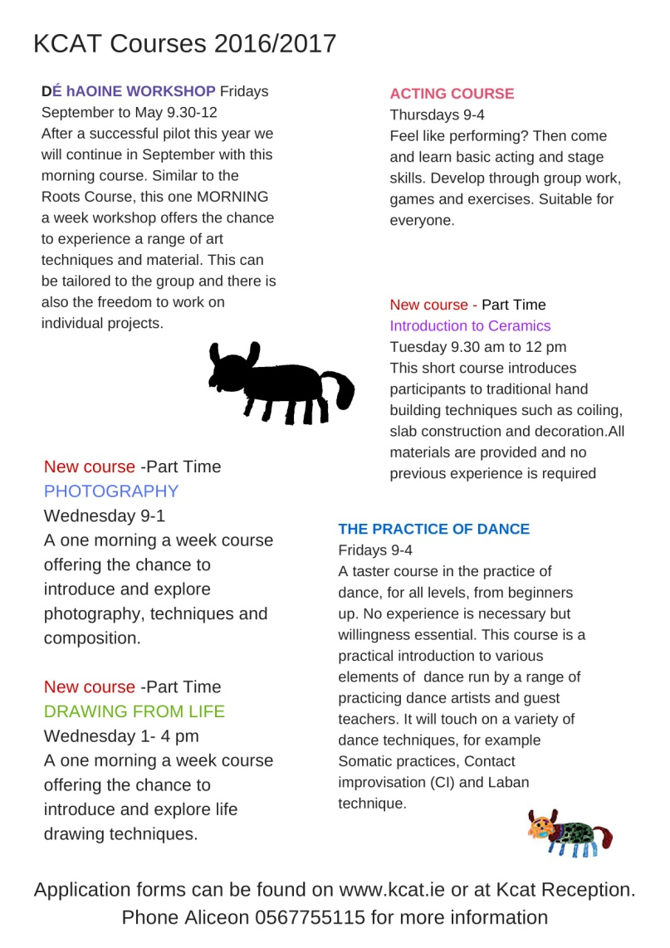

**___________________________________________________________________________**

***The Hellfire Squad* by The Devious Theatre Company**

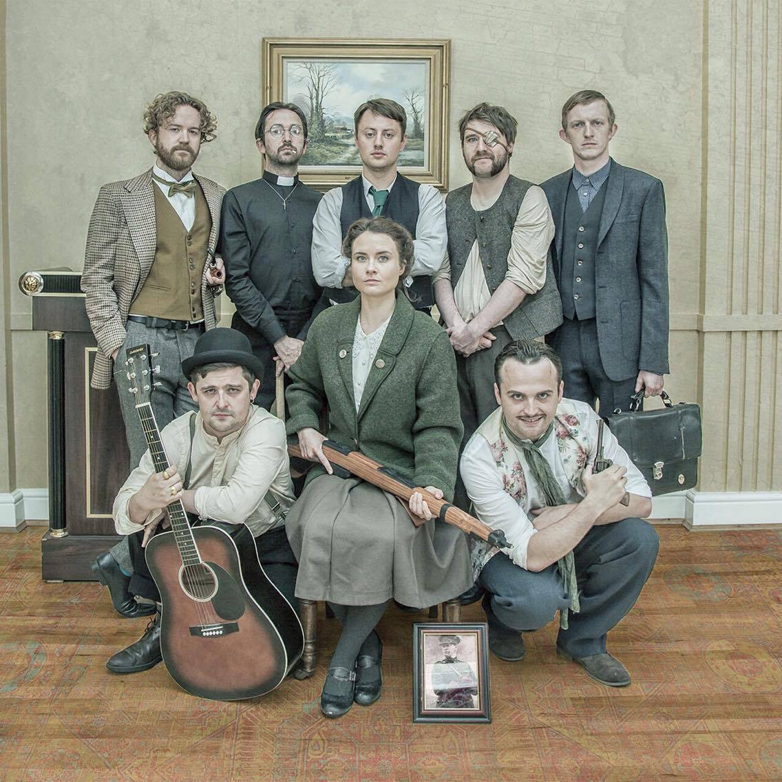

**WRITTEN by Peter McGann & John Morton**

**DIRECTED by Sarah Baxter**

**PRODUCED by Ken McGuire**

**PRODUCTION DESIGN by Helen McGinty**

**SOUND DESIGN by Ken McGuire**

**LIGHTING DESIGN by Adrian Mullan**

**PERFORMED BY Annette O’Shea (‘The Bould’ Kathleen Sweeney), David Fennelly (Tadhg McRoth), John Morton (Walter Meade), Dave Fleming (Fr. Desmond Furey), Stephen Colfer (Dr. Roddy Quincannon), John Doran (Finbarr McLiammoir), Peter McGann (Dicey McGurk), Ed Murphy (Austin De Courcey)**

**“**Collins knows the value of a ripping yarn**….”**

After the Rising, Michael Collins put together a list of the hardiest *shcans* in all 32 counties to form an elite military unit. This unit embarked on a campaign of subterfuge, misinformation, political assassination, espionage and general divilment. So begins the tale of ***The Hellfire Squad***!

This new play from **Peter McGann** and **John Morton** is a fiercely comical, action-packed story of mismatched assassins with different agendas but the same targets.

The legend of Collins’ Squad has been printed. Now the seven-man squad and their no-nonsense handler ‘The Bould’ Kathleen Sweeney are telling their tale, one as powerful, tragic and frighteningly absurd as the history from which it sprung.

*The Hellfire Squad* follows on from previous hit shows in Dublin such as ***War Of Attrition, Some Flood, The Centre Of The Universe*** and ***Scratcher***.

**LISTINGS / BOOKING INFO:**

**Venue:** Watergate Theatre, Kilkenny

**Dates:** July 28-30 at 8pm nightly.

**Duration:** 100 minutes

**Tickets:** €12 full price.

**About The Devious Theatre Company:**

**The Devious Theatre Company** was founded in Kilkenny in 2006. In 2016, they stage Devious 10, a programme of new and previous work celebrating a decade of theatre. The company works across a number of genres but stays rooted in a style of comedy, developed over the years. In 2011, they became the first theatre artists-in-residence in Kilkenny Arts Office; the company also won a PPI Award for Radio Drama. Devious’ work has featured at Cork Midsummer Festival, Dublin Fringe Festival and Galway Theatre Festival, among others. Previous presentations here at Project Arts Centre include [War Of Attrition](http://projectartscentre.ie/event/war-attrition/) and [Scratcher](http://projectartscentre.ie/event/scratcher/) (as part of The Theatre Machine Turns You On).

**The Devious Theatre Company have been described as:**

“funny, sharp, relevant and delivered with panache”  
**The Irish Times** on *War Of Attrition*

“the bang-on zeitgeisty script is backed up by excellent use of live technology, and a completely believable spiralling chain of events”  
**Irish Theatre Magazine** on *War Of Attrition*

“This young company of performers, writers, and directors have been consistently producing top notch performances. It is clear that have their finger on the pulse of what their youthful audiences want”  
**The Public Reviews**

**For more information, images or press tickets please contact:**

Ken McGuire, Producer, Devious Theatre, 086 1048191 / john@devioustheatre.com

**__________________________________________________________________________**

**WHAT welcomes its 2016 Artist in Residence to University Hospital Waterford**

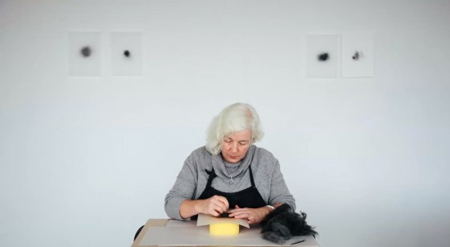

Image shown: Caroline Schofield

[WHAT](http://www.artsandhealth.ie/2016/07/06/what-welcomes-its-2016-artist-in-residence-to-university-hospital-waterford/www.waterfordhealingarts.com) (the Waterford Healing Arts Trust) is delighted to welcome [Caroline Schofield](http://carolineschofield.blogspot.ie/) to University Hospital Waterford as the 2016 Artist in Residence.

Caroline lives and works in Kilkenny. She studied Textiles in NCAD and received an MA in Art & Process from Crawford College of Art & Design in 2015. She is driven by an engagement with craft and a curiosity about narratives contained within materials from industrial steel, stone fabric, string and found objects. She manipulates and creates installations with these items referencing personal histories, place, people and memory.

Her current work focuses on materials to form a mediation with people on memory. She will explore the creative use of fabrics, wool and other materials in the life of patients in the hospital in particular she is interested in working with patients with Dementia in Medical Ward 5. She is also available to work with any patient in any ward upon request via WHAT’s Artist on Call programme.

Caroline has collaborated with artist’s, women’s and children’s groups including GKV, Netherlands, Open Circle, Kilkenny Arts office, Crafts Council of Ireland, Natalie B Coleman and Derry City of Culture.  Her work has been exhibited nationally and internationally and includes Leydon Gallery, London, Convergence, Beijing & Shanghai, Culture/Craft, Derry. Her work is in collections in Ireland and abroad and can be seen in the OPW Per Cent for Art, Kilkenny Courthouse.

For further information on WHAT’s Artist in Residence programme see <http://waterfordhealingarts.com/what-we-do/for-health-service-users/artist-in-residence/>. To organise an interview with Caroline, phone Claire Meaney at 051 842664 or email [claireA.meaney@hse.ie](mailto:claireA.meaney@hse.ie)

# ****___________________________________________________________________________****

# ****Mandala Workshop with Alice Bennett at Blackwatch Studio****

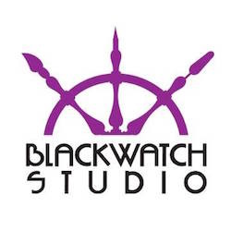

23 July  
Fee: €75 including materials.

In this workshop, artist Alice Bennett will introduce you to the practical steps of making a Mandala. Through these steps each participant will be enabled to start on a personal journey of calmness, self discovery and potentially of healing. There is no need to be artistic to create your own Mandala.

The word ”Mandala” originates from the language of Sanskrit and loosely translated means circle. It represents wholeness and can be seen as a basic structure of life itself, the world that extends both beyond and within our bodies and minds. A Mandala describes both material and non-material realities. It appears in all aspects of life: from the interior of a flower to the celestial circles we call earth, sun and moon. Mandala’s can convey the conceptual circles we belong to, friends, family and community.

Blackwatch Studio, Frenesytown, Clifden, Co Kilkenny  
T: 0868370205  
E: [**blackwatchstudiokk@gmail.com**](mailto:blackwatchstudiokk@gmail.com)  
W: [**blackwatchstudio.ie**](http://scanmail.trustwave.com/?c=6600&d=tcPh11THHiOQBK_PYveGX6Bp0DAcAv52ez6Z05nizQ&s=380&u=http%3a%2f%2fvisualartists%2eus9%2elist-manage1%2ecom%2ftrack%2fclick%3fu%3de67e46c7b14e756132f46a50c%26id%3d778ccf118a%26e%3d1968c52731)

**_______________________________________________________________________________________**

**Call For Participants’: Kilkenny Libraries Poetry Reading Event October 2016**

Inspired by America’s Favorite Poem Project, where ordinary Americans read aloud their favourite poem for an archive at the Library of Congress, and the recently published anthology in collaboration with Amnesty International “*Poems That Make Grown Women Cry”*, where the editors invited 100 prominent women in the UK to choose their favourite poem and to explain why it moved them, Kilkenny Libraries is holding a poetry reading event in October 2016 in a similar vein where local readers are invited to choose and read a poem that means something to them –an old favourite, or something new. You decide!

Kilkenny Libraries have a number of copies of “*Poems That ...*” which are available to borrow from the library branches around the county, along with other books and anthologies of poetry. The “*Poems That...”* series and others could be a starting point for choosing a poem, or readers might already have a favourite poem that they would like to read.

Kilkenny has a vibrant poetry scene and many talented poets, but for this event we would like to keep to the spirit of the Favourite Poem Project and the *“Poems That ...”–* anthology - so the favourite poem should be someone else’s work – it’s about being moved to read and communicating your reading of that poem to an audience. And you don’t have to be a poet or writer to participate! Even shy readers are encouraged to nominate someone else to read their choice for them if they wish. An all-inclusive adult event showcasing poems that are familiar, or not; poems that may be sad, joyful, celebratory, shocking, inspiring, funny or question things, but have a personal reasons for choice are all welcomed.

We would like to get everyone reading and practicing well in advance – what seems daunting now might seem perfectly feasible by October!  If you don’t have a poem chosen yet, but think you would like to read, please get in touch and get reading – you can let us know your choice of poem during the summer.

To take part in this event or if you have any questions, please contact Mary Morrissey at [mary.morrissey@kilkennylibrary.ie](mailto:mary.morrissey@kilkennylibrary.ie)

For further information on our libraries, this event and other please see [www.kilkennylibrary.ie](http://www.kilkennylibrary.ie)

WATCH THIS SPACE FOR DETAILS OF THIS FREE EVENT TO THE PUBLIC!

**___________________________________________________________________________**

**Ballykeeffe Amphitheatre – Declan O’Rourke**

The critically acclaimed Declan O’Rourke will take to the stage on July 22nd.

Launching the 2016 programme of events, Cathaoirleach of Kilkenny County Council and elected representative for the local area, Mary Hilda Cavanagh, said:

“I encourage visitors from near and far to visit the Ballykeeffe Amphitheatre this summer, not just to see a fantastic event, but to witness what great community spirit can achieve. This wonderful cultural resource was once a disused quarry but thanks to the dedication of local volunteers, it is now one of the premier cultural attractions in Kilkenny. I congratulate all those involved and look forward to attending events at Ballykeeffe Amphitheatre this summer.”

Also on hand to launch the 2016 season was local Graigue-Ballycallan clubman, Kilkenny Under-21 hurling manager and former county hurling hero Eddie Brennan.

From Chairman of Ballykeeffe Amphitheatre Matt O Sullivan:

“I am privileged to have watched Ballykeeffe Amphitheatre grow from strength to strength over the years, from humble beginnings as an abandoned quarry to a major player on Kilkenny’s very strong music and arts scene. The community involvement in Ballykeeffe Amphitheatre is what makes this venue so special, and our success is due in no small part to the local volunteers who give up their time year after year, as well as the continued support of those who attend our events. We have an excellent line-up for 2016 with something to suit all ages and interests, and look forward to welcoming everyone to Ballykeeffe for what is set to be an unmissable summer season”

For more details see <http://ballykeeffeamphitheatre.com/>

**_______________________________________________________________________________________**

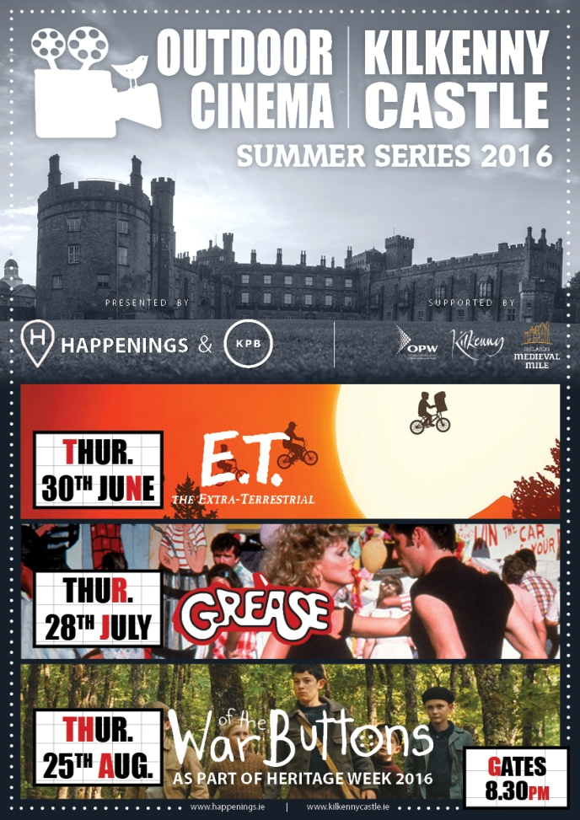

**_______________________________________________________________________________________**

**Course / Training / Jobs / Internships**

**NEW! Children’s Exhibition Curator Wanted for Dun Laoghaire-Rathdown County Council**

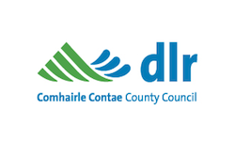Deadline: 18 August 2016

Dún Laoghaire-Rathdown County Council invites applications from curators who are interested in working with primary school children, creative practitioners and teachers to collaboratively curate an exhibition programme. The Arts Council’s Collection of 20th and 21st Century Irish Art is the source for the show. This exhibition programme will take place in May 2017 in our Municipal Gallery, dlr LexIcon. The budget assigned for the curator to this project is € 4,260.

E: mdavey@dlrcoco.ie  
For further details please go to: [**www.dlrcoco.ie/en/arts/funding-opportunities/june-dlr-arts-office-opportunities**](http://www.dlrcoco.ie/en/arts/funding-opportunities/june-dlr-arts-office-opportunities)

**___________________________________________________________________________**

**NEW! CIT Crawford College of Art and Design: Special Purpose Award, Level 8 Certificate**

**This is a CIT approved Special Purpose Award, Level 8 Certificate supported by Irish Aid.**

[http://www.creativityandchange.info](http://www.creativityandchange.info/)

**ABOUT**

Creativity & Change is about creativity and its power to ignite empathy, passion and learning about our interconnected and interdependent world.

It is about imagining more humane, just and viable ways to live in the world.

It connects how we think, live and act in the world and considers how we can live as connected global citizens becoming part of the changes we want to see.

**WHO IS IT FOR?**

Artists, community workers, youth workers, activists educators, volunteers and anyone who is interested in exploring the connection between creativity, learning and change in the world and in nurturing possibilities to grow as connected global citizens.

**COURSE CONTENT**

The course has several main strands of learning within the context of global citizenship & global and local justice themes.

* Development of confidence in personal creativity
* Creativity & learning strategies
* Facilitation skills in development education using creative methodologies
* Creative strategies for public engagement.

For online application, please go to the **APPLY** link on <http://www.cit.ie/course/CRAARPD8>

The course fee is subsidized through Irish Aid funding so it can be offered at reduced rate of €680

Enquiries to [creativityandchange@cit.ie](mailto:creativityandchange@cit.ie) or call Nora on 086 3765686

**_______________________________________________________________________________________**

|  |  |  |
| --- | --- | --- |
| |  |  | | --- | --- | | |  | | --- | | **NEW! Novel Fair 2017** | | |

|  |  |
| --- | --- |
| |  | | --- | | [Novel Fair 2017](http://scanmail.trustwave.com/?c=6600&d=kYqG1y83ZSapRd5a70VGDOZQ2gWgYfyANy0NfJFwmg&s=380&u=http://irishwriterscentre.us9.list-manage.com/track/click?u=b6ac145e44235d03eb0c4adb6&id=d0e7ad239d&e=055476dad7) | |

Described by *The Irish Times* as a '*Dragon's Den* for writers', the **Novel Fair** is an **Irish Writers Centre** initiative which aims to introduce up-and-coming writers to top publishers and literary agents, giving novelists the opportunity to bypass the slush pile, pitch their ideas and place their synopsis and sample chapters directly into the hands of publishers and agents.

Over the past few years a range of publishers and agents have attended the Fair including Penguin Random House Ireland, Hachette Ireland, Transworld Ireland, Curtis Brown, New Island Books, O’Brien Press/Brandon, Liberties Press, Lilliput Press, Tramp Press, The Book Bureau, Marianne Gunn O’Connor Literary Agency, Jonathan Williams Literary Agency, Lisa Richards Agency, Feldstein Agency and Author Rights Agency and New York based agent Regal Hoffmann & Associates.

There have been a number of success stories since the Novel Fair has been established, such as:

* Janet E. Cameron’s novel *Cinnamon Toast* (Hachette)
* Niamh Boyce’s novel *The Herbalist* (Penguin Ireland) which was longlisted for IMPAC 2015
* *Beatsploitation* by Kevin Curran (Liberties Press)
* *Here In No Place* by Alan Timmons' (New Island)
* *The Reluctant Cannibal* by Ian Flitcroft (Legend Press)
* Daniel Seery’s novel *A Model Partner* (Liberties Press)
* Susan Lanigan’s White Feathers (Brandon Press)
* *Eggshells* by Caitriona Lally (Liberties Press)
* Andrea Carter's novel *Death at Whitewater Church* (Constable & Robinson)
* *Swimming on Dry Land* by Helen Blackhurst (Seren)

The **Novel Fair 2017** submissions period is now officially open with the **deadline for applications on 21 October 2016**. The Fair itself takes place on **18** **February 2017**.

Take a look at our [video of Novel Fair 2015](https://www.youtube.com/watch?v=uPC18mdSslc) to get a flavour for just how exciting this event can be!

Before entering the competition, please ensure that you have read the **Terms & Conditions** very carefully as the Fair is open to previously **unpublished aspiring novelists** only.

<http://irishwriterscentre.ie/collections/frontpage/products/novel-fair-2017>

**_______________________________________________________________________________________**

### NEW! SAVE THE DATE: 26 August | VAI Get Together 2016

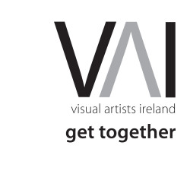We are delighted to announce that this years **Get Together** – our national day of coming together with talks, clinics, presentations, information sharing and networking will take place on Friday, 26 August 2016 in The Irish Museum of Modern Art, Dublin.

**_______________________________________________________________________________________**

[**Physical Theatre & Mask Technique Master Class with Boom Circus (US)**](http://www.isacs.ie/physical-theatre-and-mask-technique-master-class-with-boom-circus-us/)

**ISACS** are delighted to host this unique 2 day Master Class in **Physical Theatre** **and** **Mask Techniques,**in association with the [Wexford Arts Centre](http://www.wexfordartscentre.ie/) and [Waterford Spraoi,](http://www.spraoi.com/) led by **David Poznanter** and **Peter Sweet** of **Boom Circus (US) over the 26th + 27th July in Enniscorthy, Co Wexford,** just days before they set to wow the crowds at the Irish premier of their dynamic street show ‘Boom’ at Waterford Spraoi, the longest running street arts festival in Ireland over this August Bank Holiday weekend.

“*BOOM!” breathes new life into the ancient tradition of masked theatre, full of spontaneous improvisation, heartwarming drama, impossible skills and hilarious moments of sheer humanity. Peter Sweet and David Poznanter portray a cast of 6 characters who put on an entire circus, complete with slackrope, Cyr Wheel, juggling and live music*”

**This 2 day workshop will focus on:**

* Spatial awareness.
* Fixed points and articulation.
* Mask technique.
* Contact and clarity in theatrical mask improvisation

**Cost for the 2 days**

**ISACS members : €50.00** / **Non ISACS members: €100.00**

[(Sign up here for annual ISACS membership which starts at €30 per year)](http://www.isacs.ie/registration/)

**Dates:** Tuesday 26th & Wednesday 27th July

**Venue:** [Presentation Centre](http://www.presentationcentre.ie/), Enniscorthy, Co. Wexford

**Times:** 10 am- 3pm with 1 hour lunch break included.

**Booking:** Bookings can be made via Wexford Arts Centre [here](https://wexfordartscentre.ticketsolve.com/#/shows/873557508)

(Please specify if you are an ISACS member to avail of your 50% reduction! Maximum participants is 14 so early booking is recommended!)

Contact [marketing@isacs.ie](mailto:marketing@isacs.ie) with any queries you may have.

**_______________________________________________________________________________________**

**Adult Continuing Education in European Art History at UCC, Cork**

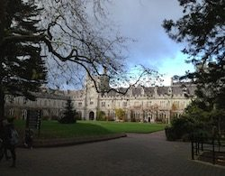

Adult Continuing Education at University College Cork is pleased to announce a new cycle of the Diploma in European Art History beginning in September 2016 and currently taking applications.

This exciting two-year programme asks the question, what is the “idea” of Europe? We will examine this question by looking at visual culture expressed through the push and pull between the metropolitan centres (such as Rome, Venice and Florence and Amsterdam) and European regions across time and space. We will examine how art functions differently from state buildings to religious settings and from public monuments to domestic spaces. We will use cultural artefacts (e.g. paintings, architecture and the decorative arts) to examine these centre/periphery tensions from Classical Antiquity to the Baroque in year one and from neo-Classicism to Modernity in year two.

Programme lectures take place on Tuesday evenings, from late September, on the main UCC campus between 7 and 10pm

For any further queries please contact James Cronin, programme co-ordinator, E: j.cronin@ucc.ie  
For further details and how to apply see [**www.ucc.ie/en/ace-dah/**](http://scanmail.trustwave.com/?c=6600&d=2v3q11HA7afVmAPzp6f0e8BJowSqiifDnKMvPWQcQg&s=380&u=http%3a%2f%2fvisualartists%2eus9%2elist-manage%2ecom%2ftrack%2fclick%3fu%3de67e46c7b14e756132f46a50c%26id%3d7fb5ad118d%26e%3df4dbf7f416)

**_______________________________________________________________________________________**

**NYCI Certificate in Youth Arts 2016/2017**

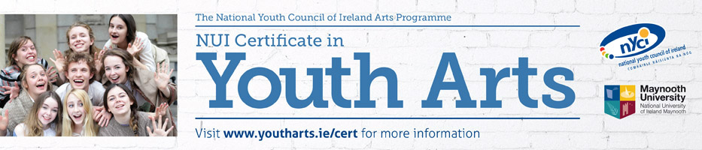

**\*\* **** Closing date for applications - Friday 19th August 2016**** \*\***

“The course gave me space and time, along with a new vocabulary to think about and therefore understand what youth arts means to me and what it means for society. This increased understanding allowed me to return to my work armed with renewed motivation, new and important contacts, increased policy and sector knowledge and a fired up imagination.”

**NUI Certificate in Youth Arts**

The **Certificate in Youth Arts** is a part time programme of study in Irish Youth Arts Practice, with 6 modules covered over 12 contact days between October and June. The programme is a partnership initiative of Maynooth University and the National Youth Council of Ireland Arts Programme and leads to an award of the National University of Ireland, placed at Level 7 on the National Qualifications Framework.

The Certificate in Youth Arts aims to introduce those working in the non-formal education sector to the concepts, principles and practice of youth arts using a context and practice approach.

**The Certificate in Youth Arts is recruiting potential candidates in summer 2016for the 2016/17 academic year. For further information or to request an application form, please contact Anna Gunning, Youth Arts Programme, National Youth Council of Ireland on 01 4255932 or** [**anna@nyci.ie**](mailto:anneog@nyci.ie)**.  We look forward to hearing from you!**

**Call for Submissions / Residencies / Public Art**

**NEW! The United Nations / Ranan Lurie Political Cartoon Awards 2016**

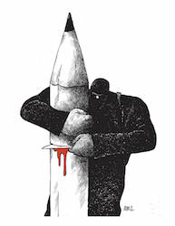

Deadline: 15 November

The United Nations / Ranan Lurie Political Cartoon Awards are now open for entries in the 2016 cartoon competition. Eligible for entry are works done from the beginning of September 2015, to the 15th of October 2016, reflecting the importance of human dignity, mutual respect and friendship among nations, as well as economic consideration and environmental responsibilities towards each other.

The total prize money fund for 2016 is $18,000, of which $10,000 are reserved for the First Prize winner, $5,000 for the Second Prize winner and $3,000 for the Third Prize winner. Plaques will also be awarded to the winners of the first three prizes. Ten (10) honorable mentions will also be announced.

Entries may be made by any professional individual and should consist of political cartoons printed in any publication and in any language.

Winning cartoons will be chosen for their high professional standards in art, political analysis of events, projection of events to come, humor, while also reflecting the spirit and principles of the U.N.

The United Nations has established this annual competition in 2005, to promote the highest standard of excellence in political cartoons. It is named after political cartoonist Ranan Lurie.

No Entry Fee to apply. For application form and further details see: [**http://lurieunaward.com**](http://scanmail.trustwave.com/?c=6600&d=3bj010oaidRlYXS9gCUiSaeo65yYb6_qrBNRr2R1hQ&s=380&u=http%3a%2f%2fvisualartists%2eus9%2elist-manage2%2ecom%2ftrack%2fclick%3fu%3de67e46c7b14e756132f46a50c%26id%3d1aa9fdcf7a%26e%3d1968c52731)

**_______________________________________________________________________________________**

**NEW! Open Call | Droichead Arts Centre Exhibition Programme 2017**

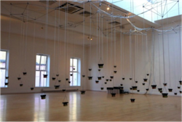

Deadline: Monday 29 August 2016

Droichead Arts Centre is now accepting proposals for its 2017 exhibition programme. The exhibition can be a solo or a group exhibition, involving any medium, and new or existing works. A gallery floor plan is available on request. Submissions should be sent in one email (not exceeding 20mb) with the subject line ‘2017 Proposal’ to: [**rita.mcquillan@droichead.com**](mailto:rita.mcquillan@droichead.com)

Submission guidelines:  
• Detailed proposal  
• Documentation of work  
• Biographies and CVs  
• Timeline for delivery  
• Technical requirements  
• Any other relevant supporting material

Droichead Arts Centre, Stockwell St., Drogheda, Co. Louth.  
T: 041 9833946  
E: [**info@droichead.com**](mailto:info@droichead.com)  
W: [**droichead.com**](http://scanmail.trustwave.com/?c=6600&d=3rj01xCdXejm_getNMEAnovK-uGLoXrJ-vR1mOdovg&s=380&u=http%3a%2f%2fvisualartists%2eus9%2elist-manage%2ecom%2ftrack%2fclick%3fu%3de67e46c7b14e756132f46a50c%26id%3db8cac8930b%26e%3d1968c52731)

**___________________________________________________________________________**

## NEW! Irish Writers’ Centre Listing of Call for Submissions for Competitions

The Irish Writer’s Centre provides a great listing of poetry, short story, prose, novel and much more creative writing competition. See their website or some of their listings here:

<http://irishwriterscentre.ie/>

[**Patrick Kavanagh Poetry Award 2016**](http://patrickkavanaghcountry.com/index.php/2016/04/04/annual-patrick-kavanagh-poetry-award-2016-2/)  
**Deadline**: 29 July 2016  
**Prize**: €10,000  
**Details**: The award is for an unpublished collection of poems in English and is open to poets, born in the island of Ireland, or of Irish nationality, or long term resident in Ireland.

[**PENfro Book Festival Poetry Competition 2016**](http://penfrobookfestival.org.uk/competitions/poetry)  
**Deadline**: 31 July 2016  
**Prizes**: 1st £300, 2nd £125, 3rd £75. Top three poems published on website. Top ten on shortlist will be invited to read at the PENfro Book Festival.  
**Details**: Fee: £4. Length: 40 lines max.

--

[**Iron Mountain Literature Festival - John McGahern Award**](http://irishwriterscentre.ie/collections/writing-opportunities/products/www.ironmountainfestival.ie)  
**Deadline**: 31 July 2016  
**Prize**: The recipient of the Award will receive  two-week fully resourced residency at the Tyrone Guthrie Centre and a stipend of €500.  
**Details**: Open to all previously published or recognized writers. All attachments should be in .pdf format. Include a cover letter, an up-to-date CV and up to three short samples of work, 300 words each.

[**Dermot Healy International Poetry Competition 2016**](http://www.fiveglensartsfestival.com/)  
**Deadline:** 3 August 2016  
**Prize:** 1st prize of €1000 and a Perpetual trophy.  
**Details:** Fee is €5 per poem submissions.

[**Bring Your Limericks to Limerick Competition 2016**](http://www.limerickwriterscentre.com/competitions/bring-your-limericks-to-limerick-competition-2016/)

**Deadline:**Tuesday 9 August.  
**Prize:**2 night’s accommodation in a Deluxe Room at the luxurious Savoy Hotel, full Irish breakfast served until noon each day and dinner in Hamptons Bar & Grill on one evening.  
**Details:**The aim of the competition is to create an awareness of the connection between the place and the poem so that Limerick can establish itself internationally as one of the few places that gave its name to a literary form. Think Shakespeare and Stratford, Joyce and Dublin, Burns and Scotland, Limerick and the Limerick. The competition is supported by the Limerick Writers’ Centre and Global Limerick Network. The final of the competition will take place in the Savoy Hotel, Limerick Sat 27th Aug 2016.

--

[**Red Line Book Festival Poetry Competition**](http://www.redlinebookfestival.ie/competitions)  
**Deadline:** Friday 12 August 2016**.**  
**Prize:** First prize is €300, second prize is €200 and the third prize is €100.  
**Details:** The competition is free to enter. Full details including the competition rules and entry forms can be found on the website.

--

[**The Ogham Stone: Call for Submissions**](http://www.theoghamstoneul.com/)

**Deadline:**Sunday 28 August.

***Details:***The Ogham Stone, the University of Limerick’s literature and arts journal, is currently inviting submissions for the Spring 2017 edition. The journal has fast become an influential platform for writers and artists to present their work, and it remains committed to showcasing exciting new work by emerging and established artists. Last year the journal published just under fifty pieces, including short stories, flash fiction, poetry and artwork, and featured new work by Irish writers Colum McCann, Paula Meehan, Joseph O’Connor and Mary O’Malley. The Spring 2017 issue welcomes submissions in fiction, memoir, poetry, visual arts and photography, short graphic novels, and creative non-fiction. So buff and shine your work and get it to us before the deadline of 28th August 2016! For detailed submission guidelines please see our website: www.theoghamstoneul.com.

--

[**The Aesthetica Creative Writing Award**](http://www.aestheticamagazine.com/creative-writing-award/)  
**Deadline**: 31 August 2016  
**Prizes**: Includes £500 prize money for the Poetry winner & £500 prize money for the Short Fiction winner; full list of prizes on the website.   
**Details**: Poetry entries should be no more than 40 lines; Fiction entries should be no more than 2,000 words. Works published elsewhere are accepted. You may enter as many times as you wish. Both Poetry and Fiction entries should be written in English.

--

[Books Ireland Short Story Competition](http://irishwriterscentre.ie/collections/writing-opportunities/products/www.booksirelandmagazine.com/competition)

**Deadline:** 31 August 2016  
**Prizes:** 1st: €400 plus a place on writing course at the Irish Writers Centre and publication in Books Ireland magazine. 2nd €200 and 3rd €100   
**Details:** 2nd Books Ireland Short Story competition. Entry is open to any nationality writing in English, with no restriction on style or theme. Maximum words allowed is 2600.

--

[**The Manchester Poetry Prize**](http://www.manchesterwritingcompetition.co.uk/Poetry-Prize.php)  
**Deadline**: 23 September 2016  
**Prizes**: £10,000  
**Details**: Entry fee is £17.50, £10,000 prize for the best portfolio of three to five poems (maximum combined length: 120 lines). Open internationally to new and established writers aged 16 or over (no upper age limit).

--

[The Caterpillar Story for Children Prize 2016](http://www.thecaterpillarmagazine.com/a1-page.asp?ID=7644&page=17)

**Deadline**: 30 September 2016.  
**Prizes:**1st Prize: €500 plus a 2-week stay at The Moth’s Artists’ Residence  
2nd Prize: €300  
3rd Prize: €200  
All three winning stories will appear in the winter 2016 issue of *The Caterpillar***Details:** Send an original, unpublished story of no more than 1,500 words – on any theme or subject, as long as it is appropriate for 7–11 year olds. The entry fee is €12 per story, and you can enter as many stories as you like.

--

[**Off the Beaten Track Writing Competition**](http://seniortravelexpert.com/off-beaten-track-writing-competition/)  
**Closing date:** 30 September 2016  
**Prize:** £100.00 cash prize plus 10 runner-up vouchers and published on website  
**Entry fee:** Free to enter  
**Length:** Maximum 750 words, fact or fiction  
We are looking for interesting, original articles which relate to the theme: Off the Beaten Track.  The winning entry will be the one that is judged to most effectively persuade readers of the **Senior Travel Expert** website that they would like to visit the place described!

--

[**The World Book of Poetry**](http://michaelosullivan59.weebly.com/world-book-of-poetry.html)  
**Deadline**: 31 October 2016  
**Details**: Poets are invited to submit poems for the World Book of **Poetry**.This is a unique opportunity for poets to find a world-wide audience for their work.

[The Ballymaloe International Poetry Prize](http://www.themothmagazine.com/a1-page.asp?ID=8010&page=13)  
**Deadline**: 31 December 2016  
**Prize:** The winner receives €10,000. Each of the other shortlisted entrants receive €1,000.  
**Details:** The Prize is open to anyone (over 18), as long as the work is original and previously unpublished. The entry fee is €12 per poem, and you can enter as many poems as you like.

**___________________________________________________________________________**

**NEW! *Metro Éireann* – Call for Submissions**

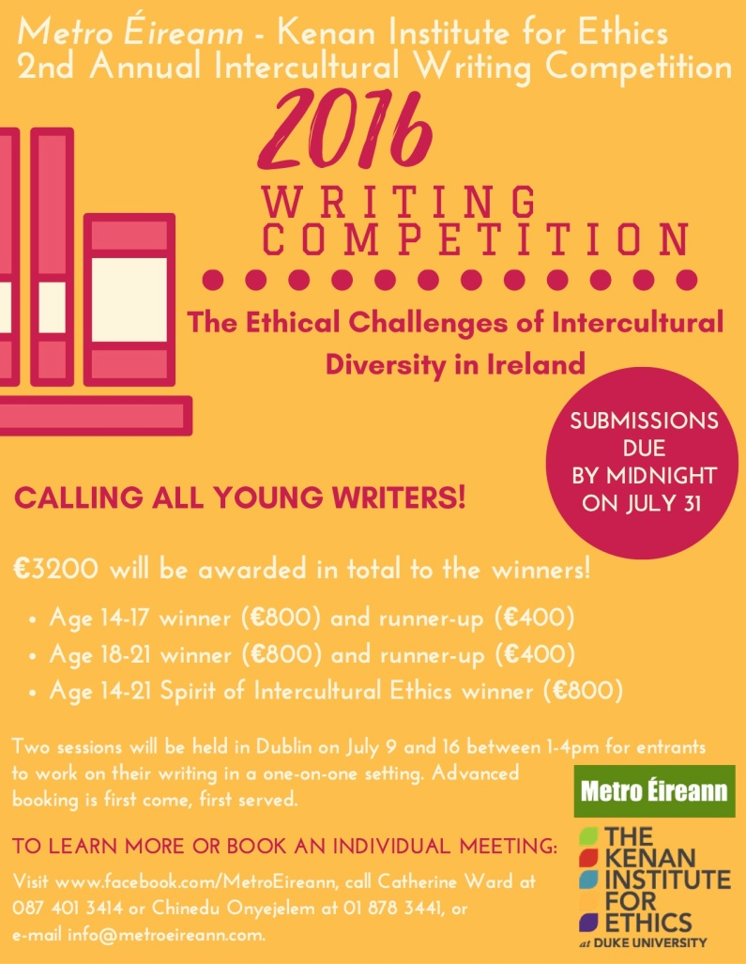

**___________________________________________________________________________**

**NEW! Curious Minds | Youth Arts Commission Call Outs**  


Deadline: Tuesday 9 August, 12 noon

Dún Laoghaire-Rathdown County Council invites applications for a youth arts commission of €8,000. We are looking for individuals or companies to create exciting, ambitious, new work with groups of young people from the local youth services in the county. You must have previous experience of working collaboratively with young people.

E: [arts@dlrcoco.ie](mailto:arts@dlrcoco.ie)

For further information please go to: [**www.dlrcoco.ie/en/arts/funding-opportunities/june-dlr-arts-office-opportunities**](http://www.dlrcoco.ie/en/arts/funding-opportunities/june-dlr-arts-office-opportunities)

**___________________________________________________________________________**

**NEW! Open Call | RUA RED Art Prize and Winter Open 2016 | (*Submission Fee)**

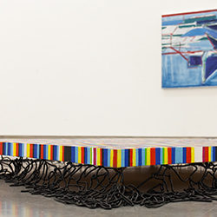Deadline: Friday 9 September, 5pm 2016

RUA RED Annual Winter Open exhibition of fine and applied arts. Submissions may be in any discipline for example painting, sculpture, new media, printmaking, ceramics, glass, photography, installation and jewellery.

This open submission is an opportunity for graduates, emerging and established artists from Ireland (including Northern Ireland) to exhibit their work in Gallery 1.

The overall winner of the RUA RED Art Prize will be awarded a solo show in Gallery 2 at some point during the ensuing 12 month period. The People’s Choice Award sponsored by The Square is determined by a public vote from visitors to the exhibition, the winner will collect €1000 towards their professional practice.

Submission details  
Artists can submit a maximum of three works. Each submission must include the following:  
• Completed Submission Form  
• Artist Statement, bio and C.V  
• Images (maximum of 3)  
• Registration and Handling Fee payable to ‘South Dublin Arts Centre Company’

A Registration and Handling Fee of €10 (inclusive of VAT) is required for each work. This payment must be submitted with the application form. No work will be considered without payment. Cheques / postal orders should be made to ‘South Dublin Arts Centre Company’.

Download Guidelines and Application form from: [**ruared.ie/about/opportunities**](http://ruared.ie/about/opportunities)

Exhibition dates: 5th November – 24th December. All sales are subject to 25% commission during the continuance of the exhibition.

RUA RED, South Dublin Arts Centre, Tallaght, Dublin 24.  
T: 01 451 5860  
E: [**info@ruared.ie**](mailto:info@ruared.ie)  
W:**[ruared.ie](http://ruared.ie/)**

**___________________________________________________________________________**

**NEW! Doire Press – open for submissions**

**Doire Press is now open for submissions for consideration of an individual full-length poetry or short story collection.**

Doire Press is looking for writers with a unique voice who have a strong publishing background and profile, and who will be proactive in promoting their work. Writers must live in Ireland.

**Short stories:**

* Query (short letter introducing yourself, saying a bit about your manuscript and why you think you are a good fit for Doire Press)
* Three short stories (12-font, double spaced, single-sided pages; no word limit)
* Biographical note (including publication/award history, website or blog address, if you have one)
* Contact information (including email address)

**Poetry:**

* Query (short letter introducing yourself, saying a bit about your manuscript and why you think you are a good fit for Doire Press)
* Fifteen poems (12-font, single spaced, single-sided pages)
* Biographical note (including publication/award history, website or blog address, if you have one)
* Contact information (including email address)

Doire Press will respond to all submissions via email. Please note that it might take up to three months to get back to you. If they like your submission and think you might be a good fit, they will ask to see a full manuscript.

Although Doire Press strongly encourage and support new writers, please understand that they don’t have time to review or give feedback on submissions.

**Closing date for applications:** Sunday 31st July.

Printed copies will only be accepted. Please send it to:  
Doire Press  
Aille  
Inverin  
County Galway

**For more information please visit** [**doirepress.com**](http://www.doirepress.com/submissions/)

**___________________________________________________________________________**

## NEW! Open Call for a Socially Engaged Commission at Tate Liverpool as part of the Collaborative Arts Partnership Programme funded by Creative Europe



**Salary:** Project budget: 40,000 GBP (approximately 50,000 EUR)

**Location:** Liverpool - Tate Liverpool

**Closing date:** 30 August 2016 at midnight

Tate Liverpool is fully committed to challenging the ways in which art is presented to the public and how this can evolve through working in social contexts.   
  
To this end Tate Liverpool opens the call for collaborative socially engaged artist/s born in or resident in the UK, Ireland, Spain, Finland, Hungary or Germany, (partner countries within the Collaborative Arts Partnership Programme).   
  
The brief is to research and deliver a new commission in Spring, 2017. The commission process will include a research period with the opportunity to develop a new work at Tate Liverpool, in collaboration with local communities and a network of established partners in the North of England and beyond.   
  
It is envisaged that artists will work with local communities outside the institution as well as use the top floor gallery space at Tate Liverpool throughout April 2017.   
  
Artists should have experience of working in the field of collaborative socially engaged practice, understand the ethical issues involved, be relevant to local conditions and engage a broad audience.   
  
Individual artists or artist collectives are invited to submit draft proposals by 30 August 2016.   
  
This Commission is part of the Collaborative Arts Partnership Programme, find more information at [www.create-ireland.ie](http://scanmail.trustwave.com/?c=6600&d=1NX_1wHjqETl8cEV3ehdUi0zX5B58_llBG1PbOWoqg&s=380&u=http%3a%2f%2fwww%2ecreate-ireland%2eie)

Supported by the Creative Europe programme of the European Union (Culture Sub-Programme) Support for European Co-operation Projects Education, Audiovisual and Culture Executive Agency.

### Application Information

For full details about this open call and what is required within your submission,

**Deadline for proposals  
August 30, 2016 to**[opencall@tate.org.uk](mailto:opencall@tate.org.uk) **Please use this email address for further information and any queries.**  
Information is also listed on [tate.org.uk](http://scanmail.trustwave.com/?c=6600&d=1NX_1wHjqETl8cEV3ehdUi0zX5B58_llBD0Za-D79g&s=380&u=http%3a%2f%2fworkingat%2etate%2eorg%2euk%2fpages%2fjob%5fsearch%5fview%2easpx%3fjobId%3d2887%26JobIndex%3d3%26categoryList%3d%26workingPatternList%3d%26locations%3d%26group%3d%26keywords%3d%26PageIndex%3d1%26Number%3d25)  
[http://www.e-flux.com/announcements/open-call-for-a-socially-engaged-commission/](http://scanmail.trustwave.com/?c=6600&d=1NX_1wHjqETl8cEV3ehdUi0zX5B58_llBGsUPbL7pQ&s=380&u=http%3a%2f%2fwww%2ee-flux%2ecom%2fannouncements%2fopen-call-for-a-socially-engaged-commission%2f)

**___________________________________________________________________________**

**NEW! Open Call to Members | 126 Exhibition Programme 2017**

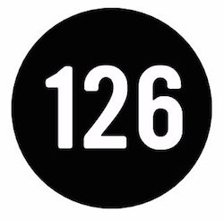126 Artist-Run Gallery is planning their programme for 2017 and are currently accepting submissions for solo and group exhibitions from member artists and curators. 126 prioritises experimental, risk-taking contemporary visual art.

To submit a proposal please send a letter of intent, C.V., approx. 10 images of work (in one PDF) to: [**contact@126.ie**](mailto:contact@126.ie)  
Use the subject line: ‘Submissions 2016’ in your email.

For a floor plan of our new space, please click here: [**126.ie/submissions-2/**](http://126.ie/submissions-2/)  
You must be a current member of 126 to submit for an exhibition, to renew your membership or join our growing international membership base, please click, here: [**126.ie/membership/**](http://126.ie/membership/)

126 Artist-Run Gallery  
19 St Bridgets Place, Woodquay, Galway  
T: 0864491366  
E:**[contact@126.ie](mailto:contact@126.ie)**  
W: [**126.ie**](http://126.ie/)

**___________________________________________________________________________**

**NEW! 8 Weeks Left to Enter the Aesthetica Art Prize 2016: Prizes Include Exhibition & £5,000**

There are 8 weeks left to enter the Aesthetica Art Prize 2016, with major prizes including **£5,000** courtesy of Hiscox, a group **exhibition**, **publication** in an anthology and **editorial** **coverage** in Aesthetica Magazine (311,000 readership).

Now in its 10th year, the Aesthetica Art Prize is an excellent opportunity for aspiring and established artists to showcase their work to wider, international audiences. Previous winners and longlisted artists have achieved further recognition world-wide, and have been featured in exhibitions and private collections.

**Prizes include:**

•         £5,000 Main Prize Winner, courtesy of Hiscox

•         Group exhibition hosted by Aesthetica

•         Editorial coverage in Aesthetica Magazine

•         Publication in the Aesthetica Art Prize Anthology

•         £250 art supplies vouchers, courtesy of Winsor & Newton

•         A selection of art publications from Prestel Books

Categories for entry: Photographic & Digital Art; Painting & Drawing; Three Dimensional Design & Sculpture, and Video, Installation & Performance.  
  
Submissions close 31 August 2016. To enter, visit [www.aestheticamagazine.com/art-prize/enter](http://scanmail.trustwave.com/?c=6600&d=6M2G1zBv66aUOhkZpLcZp-RNleN5mpjZGOzHfzc5Xw&s=380&u=http%3a%2f%2fwww%2eaestheticamagazine%2ecom%2fart-prize%2fenter)

**___________________________________________________________________________**

**NEW! Call for 3 Minute Film Challenge Submissions, Wexford Documentary Film Festival**

Closing Date for submissions: 29 August 2016  
The 4th Wexford Documentary Film Festival 9th to 11th September 2016

...

The Wexford Documentary Film Festival will takes place in the fishing village of Kilmore Quay, County Wexford. This film festival provides the opportunity to see award winning national and international documentary films. The festival has a strong emphasis to screen films that explore social, political and environmental concerns whilst also including a number of artists films and a 3 minute film challenge submission. All film screenings at festival are free and open to the public.

[www.facebook.com/WexfordDocufest/photos/](NULL)

**___________________________________________________________________________**

**NEW! Associate Artist 2016-17: Dance Ireland Open Call**

Dance Ireland is seeking our next Associate Artist!  After four successful years of this growing programme, and seven Associate Artists to date, this year our focus is on Traditional Irish Dance, or on an individual, collective or company whose practice is derived from this genre.  Dance Ireland has committed a €10,000 cash award to this opportunity, supplemented by other valuable, non-financial resources including studio time, administrative supports, advice and access to our national and international contacts and networks.  
   
**The** **application deadline is 05 August at 12 noon** and, as always, if you have any queries do not hesitate to get in touch.  The successful applicant will undertake their year as DI Associate Artist from September 2016-August 2017.

See [www.danceireland.ie](http://www.danceireland.ie)

**___________________________________________________________________________**

**RTÉ’s new TV programme Painting The Nation – Call for Applications**

Are you a talented amateur artist with a passion for painting? Do you love your oils, watercolours, pastels and acrylics - and would you like to showcase your painting talents to the nation? RTÉ is looking for the best amateur painters across the country to take part in this exciting new series that gives aspiring artists a real opportunity to make their mark.

**Painting The Nation** is open to a mix of painters: maybe you went to art college but ended up in another career; maybe you sell a painting or two but its’ not your main source of income; maybe you just love to paint.

This is a competition to uncover and showcase the best amateur painting talent across the island of Ireland. If painting is your passion and you think you have what it takes, we would like to hear from you.

Speaking about her new show, Pauline McLynn said: “*I am really excited to be involved in Painting the Nation. We are looking for passion mixed with real talent, and I would encourage amateur painters out there who think they have what it takes to apply to be part of the show.”*

**How To Apply**

If you are 18 and over on August 1st 2016 you can download an application form at: [http://www.rte.ie/tv/audienceparticipation/](http://scanmail.trustwave.com/?c=6600&d=_e3r1wF9in_5txVHmK6nBqoALvJsIbFPxhq3Pprf8g&s=380&u=http%3a%2f%2fwww%2erte%2eie%2ftv%2faudienceparticipation%2f)

If you would like further information or an application form sent to you please contact Andrew Mills on **01-7088135**or Ciara Kerrigan on **01-7088184**, or email us at**:**[**paintingthenation@indiepics.ie**](mailto:paintingthenation@indiepics.ie)

**___________________________________________________________________________**

**Fingal County Council Graduate Award 2016 in Partnership with Block T**

Fingal County Council Arts Office and BLOCK T are delighted to announce its Graduate Award as part of FUEL, BLOCK T’s Visual Arts Programme dedicated to the support and professional development of recent graduates. As part of an ongoing commitment to professional artists Fingal County Council’s Arts Office are offering a one-year Graduate Studio Award in BLOCK T with a solo exhibition in 2017.

Now in its third year, the residency will be offered to one graduate, the opportunity is part of a series of initiatives by Fingal Arts Office to promote and support the professional practice of emerging artists. It will provide an ideal environment for the development of a graduates practice and an opportunity to network with other artists.

Closing date: 29 July

For further information please email denise.reddy@fingal.ie  
[**www.fingalarts.ie**](http://scanmail.trustwave.com/?c=6600&d=2f3q11fTtd9HUCvOPL8ih8qB4Ijy_J98HfEtpRQt1w&s=380&u=http%3a%2f%2fvisualartists%2eus9%2elist-manage%2ecom%2ftrack%2fclick%3fu%3de67e46c7b14e756132f46a50c%26id%3d06521d28e9%26e%3df4dbf7f416) |  [**www.blockt.ie**](http://scanmail.trustwave.com/?c=6600&d=2f3q11fTtd9HUCvOPL8ih8qB4Ijy_J98HaEqoRUr1Q&s=380&u=http%3a%2f%2fvisualartists%2eus9%2elist-manage1%2ecom%2ftrack%2fclick%3fu%3de67e46c7b14e756132f46a50c%26id%3d0cba8c84d4%26e%3df4dbf7f416)

**_______________________________________________________________________________________**  
  
**D.I.V.A. Collaborative Art Project at Electric Picnic 2016**

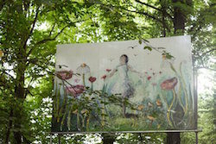

D.I.V.A. stands for Diverse Individual Visual Artists and aims to bring professional visual artists together to collaborate with one another within Electric Picnic’s unique environment and alongside the wider festival team. A bursary of €10,000 will be offered to the successful artists to help create an amazing backdrop to your festival experience.

Electric Picnic is calling on artists to come together to create something magical for the forthcoming festival. The weekend of 2nd, 3rd, 4th of September will see 55,000 people descend on Stradbally. You can apply as a group of artists who would like to take an opportunity to work together or in tandem in this environment. Alternatively you can apply as an individual artist, and should you be successful you will be grouped with 2-3 other artists with whom you will collaborate.

The artists awarded the D.I.V.A. residency will work onsite over a two week period, during the “build phase” of the festival. Works must be completed and installed by the 25th of August. The process will involve a dialogue with co-curators to ensure that the artworks created suit the festival environment, both visually and practically. For this reason, it should be expected that the final artwork may deviate from the original concept.

You do not need to develop a proposal in order to apply for the D.I.V.A. programme. The most important evidence of your ability is your past work, so please make sure and send lots of images.

TO APPLY, simply email images to: [**sorcha@eventdesignstudio.ie**](mailto:sorcha@eventdesignstudio.ie)

More information, including terms and conditions here: [**www.electricpicnic.ie/news/artists-residence-diva**](http://scanmail.trustwave.com/?c=6600&d=2f3q11fTtd9HUCvOPL8ih8qB4Ijy_J98HfQppUAvgg&s=380&u=http%3a%2f%2fvisualartists%2eus9%2elist-manage2%2ecom%2ftrack%2fclick%3fu%3de67e46c7b14e756132f46a50c%26id%3d45f3c82d1e%26e%3df4dbf7f416)

**_______________________________________________________________________________________**

**Open Call for Exhibitions and Studios Membership | Custom House Studios 2017/18 Programme**

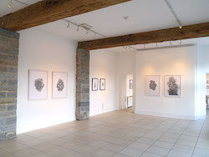Deadline: 31 September 2016

Custom House Studios are now inviting submissions for Exhibitions and Studios for 2017/18. Please submit proposals for exhibitions at the Custom House Studios gallery during 2017/18, and for use of studios ( short term contracts 1 – 3 months) in 2017/18, and long term studios in 2017/8 .

Submissions by Email – include all letters of interest, CVs and documentation of work maximum 10 images in one attached file only in PDF format, (no JPGS or other image formats accepted). For work on video please provide links for online viewing. Send to: [**customhouse@eircom.net**](mailto:customhouse@eircom.net)

For more information:  
T: +353 (0)98 28735  
E: [**info@customhousestudios.ie**](mailto:info@customhousestudios.ie)  
W: [**customhousestudios.ie**](http://scanmail.trustwave.com/?c=6600&d=2f3q11fTtd9HUCvOPL8ih8qB4Ijy_J98Ha50qRV5gA&s=380&u=http%3a%2f%2fvisualartists%2eus9%2elist-manage1%2ecom%2ftrack%2fclick%3fu%3de67e46c7b14e756132f46a50c%26id%3d6117d9a499%26e%3df4dbf7f416)

**_______________________________________________________________________________________**

**Open Call for Emerging Artists | BLOOOM Awards 2016, Germany**

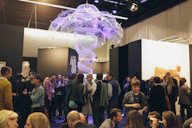Deadline: 31 July

BLOOOM Award by Warsteiner, the international competition for emerging artists, is now open for entries for 2016 and inviting artists around the world to participate.

Eligible for entry are artists who knowingly work at the interfaces between art and creative industries, whose works blur boundaries of traditional forms of expression. Visual arts, Design, Urban art or Video – the artistic potential is not limited in this competition.

This year, a total of ten 10 prizes will be awarded and they include exhibition and mentoring opportunities, sponsorships and trips to different art festivals. BLOOOM Award consciously takes responsibility for the participating artists and is distinguished by a long-term support. For one year, the winner will be actively supported in his/her career: As part of a one-year mentoring by one of the jury members, the winner defines goals with the mentor to boost his/her career. Next steps are planned together and the winner benefits from the contacts and experience of his mentor. (Information on selection panel: [**www.blooomawardbywarsteiner.com/Jury_members**](http://scanmail.trustwave.com/?c=6600&d=2f3q11fTtd9HUCvOPL8ih8qB4Ijy_J98HaYqoxt70A&s=380&u=http%3a%2f%2fvisualartists%2eus9%2elist-manage1%2ecom%2ftrack%2fclick%3fu%3de67e46c7b14e756132f46a50c%26id%3d3806dd21ad%26e%3df4dbf7f416))

All ten finalists will get the chance to exhibit their works during BLOOOM – the converging art show in Cologne, Germany in front of 35,000 visitors.

Since its beginning in 2010, BLOOOM Award emphasizes interdisciplinarity, power of innovation, courage and progressiveness. For the last edition, more than 1,500 artists applied from 75 countries.

No entry fee. To apply see: [**www.blooomawardbywarsteiner.com/Application**](http://scanmail.trustwave.com/?c=6600&d=2f3q11fTtd9HUCvOPL8ih8qB4Ijy_J98Hacp9RN61w&s=380&u=http%3a%2f%2fvisualartists%2eus9%2elist-manage1%2ecom%2ftrack%2fclick%3fu%3de67e46c7b14e756132f46a50c%26id%3ded1b3432fe%26e%3df4dbf7f416)

**_______________________________________________________________________________________**

**Accepting Applications for VAI / DAS Residency Award 2016**

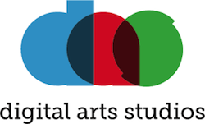

Application deadline: Midnight, July 29th, 2016  
Digital Arts Studios, 38-42 Hill St, Belfast

Applications are now being accepted for the 5th VAI @DAS Residency Award.

The award is open to all professional artists who are members of VAI. The residency at the Digital Arts Studios, Belfast, will run from October 2016 to January 2017 inclusive. The successful applicant will have their own MAC workstation in the shared studios with 24-hour access. They will also have access to a range of audio-visual equipment, assistance from DAS staff, providing the opportunity to develop their practice over the 4 months among a group of peer artists.

Apply online by submitting a proposal, examples of work and a CV at [**digitalartsstudios.com/residencies**](http://scanmail.trustwave.com/?c=6600&d=2P3q1xUHlw54DiYDsLZx_HVK0fGJ_2pAZURutENmIw&s=380&u=http%3a%2f%2fvisualartists%2eus9%2elist-manage1%2ecom%2ftrack%2fclick%3fu%3de67e46c7b14e756132f46a50c%26id%3d96ecc86c3d%26e%3df4dbf7f416)

**___________________________________________________________________________**

**Open Call for Exhibition Programme 2017, The Séamus Ennis Arts Centre, Co. Dublin**  
  
Category: Open Call  
Deadline: 20 September  
Web: [www.tseac.ie/page/apply-to-exhibit](http://scanmail.trustwave.com/?c=6600&d=pM7i12yOQajFCE1hfMU9hOP94_6BJw57h_QPBqPQ2A&s=380&u=http%3a%2f%2fcreate-ireland%2eus11%2elist-manage1%2ecom%2ftrack%2fclick%3fu%3dae8a0e4da904d891196932bf8%26id%3d295a1071d5%26e%3dff568af62e)   
Email: [info@tseac.ie](mailto:info@tseac.ie)  
  
The Séamus Ennis Arts Centre is currently looking for exhibition proposals from artists for solo/two person exhibitions in their Easter Snow Gallery for 2017. All 2D or wall mountable work acceptable including paintings, prints, drawings, photography, etc. Exhibitions will run for eight weeks.  
  
To submit a proposal send five images of recent work on a CD/USB key, Artist CV and Artist Statement/Exhibition Proposal to Colette Lawless, Séamus Ennis Arts Centre, Naul, Co. Dublin.  
  
Please contact Colette with any questions at [info@tseac.ie](mailto:info@tseac.ie)

**__________________________________________________________________________**

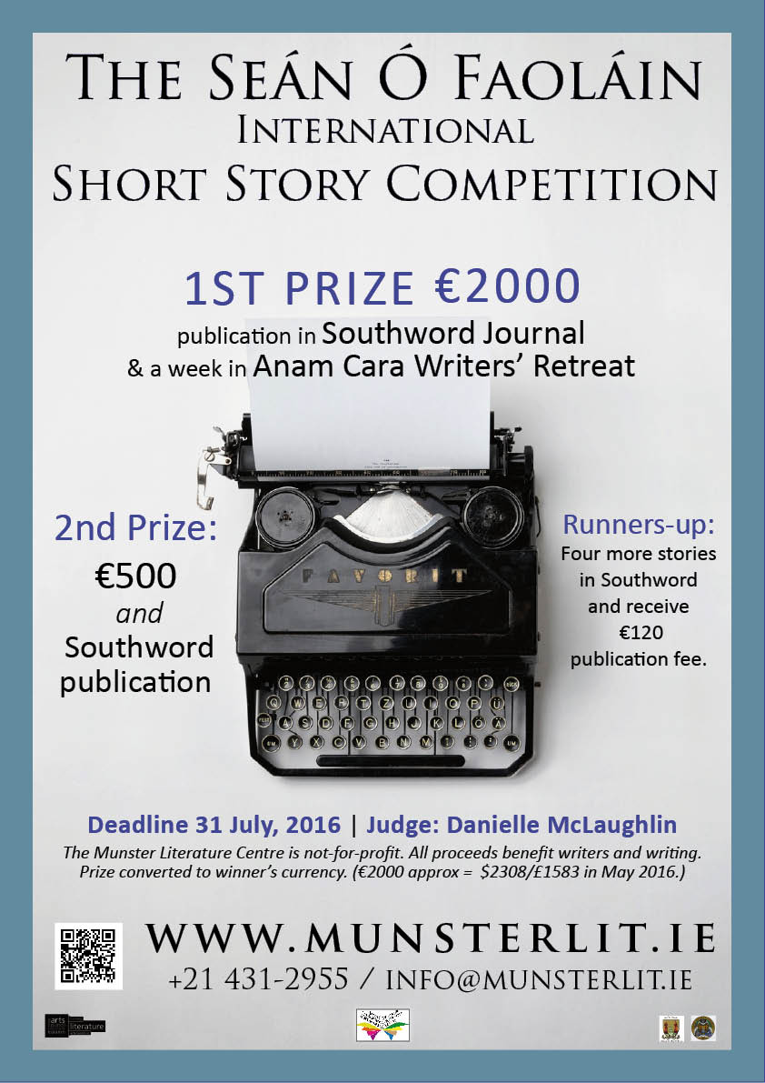

**____________________________________________________________________________________**

**Per Cent for Art Commission | St. Raphael’s College, Loughrea, Co. Galway**

Deadline for Stage 1 entries: Monday 15 August, 12 noon.

St. Raphael’s for their Per Cent for Art project would like to commission a Professional Artist(s) who can provide them with a new, permanent artwork that would involve engagement with their students and staff. St. Raphael’s College was founded in 1917. It was originally a Mercy Sister’s Convent. They wish to have their Per Cent for Art Commission completed for the official opening of the new school building in September 2017 and to celebrate the school centenary.

**Total Budget**: €35,000 (inclusive of VAT).

Applicants are requested to read the full content of the briefing document carefully as it contains important information pertaining to all stages of the commission.

**Queries:**  
Applicants can make enquiries regarding the commission to Rina Whyte, email [**rinawhyte@yahoo.com**](mailto:rinawhyte@yahoo.com) or by telephone + 353 87 238 9591.

**___________________________________________________________________________**

**2016 Over The Edge New Writer of The Year competition**

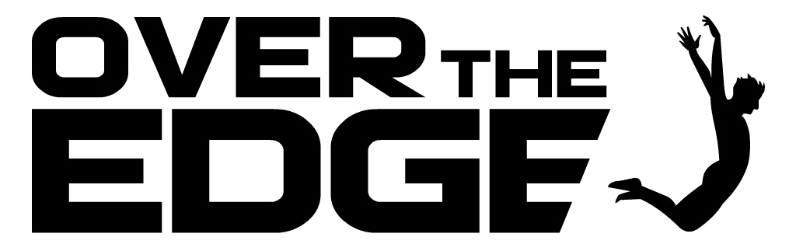

Competition judge: Niamh Boyce

Closing date: Wednesday, August 3rd , 2016

In 2016 Over The Edge is continuing its exciting annual international creative writing competition. Since its inception in 2007, it has grown to become one of the most important competition’s for emerging writers in Ireland and internationally. The competition is open to both poets and fiction writers worldwide. The total prize money is €1,000. The best fiction entry will win €300. The best poetry entry will win €300. One of these will then be chosen as the overall winner and will receive an additional €400, giving the overall winner total prize money of €700 and the title *Over The Edge New Writer of The Year 2016*. The 2016 Over The Edge New Writer of The Year will be a Featured Reader at Ireland’s leading literary reading series, the Over The Edge: Open Readings in Galway City Library, on a date to be scheduled in Winter 2016/17. [Salmon Poetry](http://scanmail.trustwave.com/?c=6600&d=uKvV1_C7H62XpQDu13p76LwimUA6_d2cjg2IFtQMoQ&s=380&u=http%3a%2f%2fwww%2esalmonpoetry%2ecom%2f) will read, without commitment to publish, a manuscript submitted to them by the winner in the poetry category. [Doire Press](http://scanmail.trustwave.com/?c=6600&d=uKvV1_C7H62XpQDu13p76LwimUA6_d2cjg3URoEK9g&s=380&u=http%3a%2f%2fwww%2edoirepress%2ecom%2fHOME%2ehtml) will read, without commitment to publish, a manuscript of short stories submitted to them by the winner in the fiction category. The overall winner will receive a hamper of books for the famous Kenny’s Bookshop of Galway, Ireland.The winner in the poetry category will have one of the poems from her or his winning entry published in the Spring 2017 issue of [*Skylight47*](http://scanmail.trustwave.com/?c=6600&d=uKvV1_C7H62XpQDu13p76LwimUA6_d2cjl2GR4cE8A&s=380&u=https%3a%2f%2fwww%2efacebook%2ecom%2fpages%2fSkylight-Poets%2f300308123389317) magazine.

 For all details and to enter see:

[www.overtheedgeliteraryevents.blogspot.com](http://scanmail.trustwave.com/?c=6600&d=uKvV1_C7H62XpQDu13p76LwimUA6_d2cjgeAR4EN8g&s=380&u=http%3a%2f%2fwww%2eovertheedgeliteraryevents%2eblogspot%2ecom)

**_______________________________________________________________________________________**

**Open Call | OpenART Biennial 2017, Sweden**

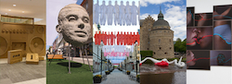

Deadline: 2 August

OpenART is Scandinavia’s biggest public art biennial and takes place in Örebro, Sweden. The city centre is filled with unexpected art that makes people feel happy, disturbed and provoked. Contemporary art from all over the world is showcased for almost three months in the city and offers unexpected encounters. The biennial challenges the visitors to rethink the perception of public space and our way of consuming and digesting art. The cultural exchange with the public is valued through several projects in connection to the exhibition like kids activities, a DIY art course and guided tours. OpenART 2017 will take place from 18 June to 10 September 2017.

Applications are made on the OpenART website, applicants must register and upload images directly at: [opencall.openart.se/Account/](https://opencall.openart.se/Account/Index?ReturnUrl=%2F)

You can enter 3 existing artworks or projects at most per application.  
The submission fee is 300 SEK (approx. €32).

Confirmed artists will receive an artist fee of €1000 (a confirmed group will share €1000), transport, travel and accommodation support. OpenART bears the cost for the transportation to and from the exhibition. In some cases OpenART also provides production support and in dialogue with the artist to find the most appropriate, time-efficient and cost-effective solutions. Artists are expected to participate in the installment of their own artworks. And are also invited to help fellow artists with production and installment on a voluntarily basis. All artists are invited to a set program on the opening weekend of OpenART 2017.

Please send your inquiries to [openart@orebro.se](mailto:openart@orebro.se)

**__________________________________________________________________________**

**Hennessy Portrait Prize 2016 l National Gallery of Ireland**

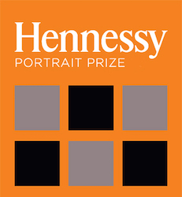

Deadline: 29 July

Application forms for the 2016 competition are now available to download, all submissions must be made online. The Hennessy Portrait Prize is open to artists across all disciplines and aims to encourage interest in contemporary portraiture and raise the profile of the National Portrait Collection. The winner will be announced in November and will once again receive a prize of €15,000 and a commission worth €5,000 to produce a portrait for inclusion in the National Portrait Collection.

For rules and application forms see: [**www.nationalgallery.ie/**](http://www.nationalgallery.ie/en/aboutus/ThisWeek/Hennessy_Portrait_Prize.aspx)

National Gallery of Ireland, Clare Street, Dublin 2

E: [**info@ngi.ie**](mailto:info@ngi.ie)  
T: (01) 661 5133

**Awards / Bursaries / Schemes**

**NEW! Jack Harte Bursary 2017**

[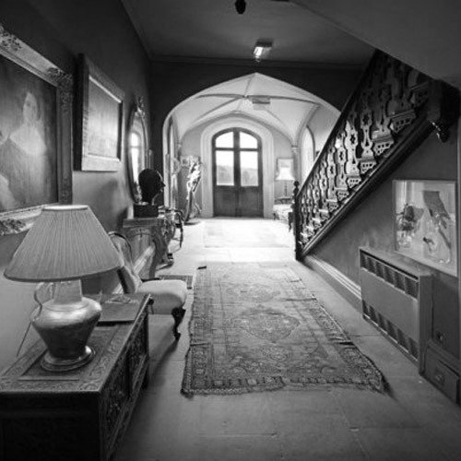](http://cdn.shopify.com/s/files/1/0631/7333/products/Annaghmakerrig_BW.jpg?v=1468346406)

**Announcing the third year of the Jack Harte Bursary awarded by**

**the Irish Writers Centre in association with the Tyrone Guthrie Centre**

The Irish Writers Centre and the Tyrone Guthrie Centre at Annaghmakerrig have come together again to offer a two-week fully resourced Writer-in-Residence Bursary to take place in spring 2017. The award is named in honour of Jack Harte, founder of the Irish Writers Centre, in celebration and acknowledgement of his contribution to Irish literature. Liz Nugent and Sarah Moore Fitzgerald have previously received this award.

**Who Can Apply:**

This is an open call to writers resident on the island of Ireland with a proven track record and at least one book of fiction or short stories published by a recognised publisher. Priority will be given to works of fiction.

**Application Deadline:**23 Friday September, 2016 at 5pm.

<http://irishwriterscentre.ie/collections/writing-opportunities>

**___________________________________________________________________________**

**NEW! Arts Council of Ireland Funding**  
  
Category: Project Awards across artforms  
Web: [http://www.artscouncil.ie/](http://scanmail.trustwave.com/?c=6600&d=rOKG103TtiVSoAgZNtsEAWnB-kT9TQVVlzPYCb7dAQ&s=380&u=http%3a%2f%2fcreate-ireland%2eus11%2elist-manage%2ecom%2ftrack%2fclick%3fu%3dae8a0e4da904d891196932bf8%26id%3dc57ed7f23d%26e%3dff568af62e)  
  
Below awards will be open for applications on 19 July:  
  
**Dance Project Award | Deadline: 18 August, 5.30pm**  
The dance project award supports initiatives in the field of dance commencing on or after 1 January 2017.  
  
Established dance artists with five years or more of professional experience may apply for up to €50,000.  
Emerging dance artists with two or more years of professional experience may apply for up to €20,000.  
  
**Music Project Award | Deadline: 18 August, 5.30pm**  
The music project award supports specific projects in the field of music commencing on or after 1 January 2017.  
  
**Opera Project Award | Deadline: 18 August, 5.30pm**  
The award is intended to support the making and presentation of opera productions during 2017, in line with the Arts Councils published policy for opera.  
  
**Theatre Project Award | Deadline: 18 August, 5.30pm**  
The award supports projects commencing on or after 1 January 2017.  
  
There are four strands to the award:  
Strand 1 – Play Development (up to €10,000)  
Strand 2 – Theatre Creation (up to €25,000)  
Strand 3 – Theatre Presentation (up to €50,000)  
Strand 4 – Theatre Production (up to €150,000)  
  
**Traditional Arts Project Award | Deadline: 18 August, 5.30pm**  
The traditional arts project award supports initiatives in the field of traditional music, song, dance and the oral arts commencing on or after 1 January 2017. The purpose of this award is to support stand-alone projects which enrich the traditional arts landscape by facilitating artists in bringing large scale innovative, ambitious and high-quality projects to audiences.  
  
**Visual Arts Project Award | Deadline: 18 August, 5.30pm**  
The visual arts project award supports specific projects and initiatives in the field of visual arts commencing on or after 1 January 2017.  
  
Please note that there will only be one round of the Project Award in Visual Arts in 2017. This means that the upcoming deadline of 18 August 2016 for the project award round 1 2017 will be the only available award for visual arts projects taking place in 2017. Please note that any application made under this round must commence by November 2017 at the latest.  
  
The award guidelines can be downloaded from the [available funding](http://scanmail.trustwave.com/?c=6600&d=rOKG103TtiVSoAgZNtsEAWnB-kT9TQVVl26ID72BUg&s=380&u=http%3a%2f%2fcreate-ireland%2eus11%2elist-manage%2ecom%2ftrack%2fclick%3fu%3dae8a0e4da904d891196932bf8%26id%3ddd95470be0%26e%3dff568af62e) section of the Arts Council's website.  
  
Applications will only be accepted through the Arts Council's [online services website](http://scanmail.trustwave.com/?c=6600&d=rOKG103TtiVSoAgZNtsEAWnB-kT9TQVVlz2PWLvTUQ&s=380&u=http%3a%2f%2fcreate-ireland%2eus11%2elist-manage1%2ecom%2ftrack%2fclick%3fu%3dae8a0e4da904d891196932bf8%26id%3db804672360%26e%3dff568af62e) and all supporting material must be submitted online. Applicants who have not previously used the online services site must [register in advance](http://scanmail.trustwave.com/?c=6600&d=rOKG103TtiVSoAgZNtsEAWnB-kT9TQVVl2nfCOrWCQ&s=380&u=http%3a%2f%2fcreate-ireland%2eus11%2elist-manage%2ecom%2ftrack%2fclick%3fu%3dae8a0e4da904d891196932bf8%26id%3db6ed0f20cb%26e%3dff568af62e) of making an application.  It may take up to five working days for your registrations to be confirmed so it is very important that you register as early as possible.

**___________________________________________________________________________**

**NEW! Arts Council Northern Ireland | Rosy James Memorial Trust Award**

Deadline: 26 August, 4pm

An annual bursary, the Rosy James Memorial Trust Award, worth £15,000, is open for applications. This unique bursary aims to assist craft makers to develop their careers by creating a new body of work which would otherwise have been unattainable without the funding award.

Administered by the Arts Council of Northern Ireland, the Rosy James Memorial Trust Award, established in 2014, came about thanks to the generosity of Rosemary James (Rosy), a local pioneer and patron of the arts. Originally from Belfast, Rosy had a lifelong commitment to the arts and following her death in 2010, bequeathed over £500,000 to help artists and craft makers pursue their careers. The fund will award one bursary of £15,000 per year.

Silversmith Stuart Cairns received the bursary in 2014 using the funds to enable him to extend and develop his practice through an extended period of regular research and investment into new equipment. The bursary enabled Stuart to produce a new body of work, for exhibiting locally, nationally and internationally, which explored landscape, process and object through the reinterpretation of domestic forms.

The Rosy James bursary scheme, now in its third year, provides a unique opportunity for the development of exciting new work which probably would not otherwise be created. It gives artists the chance to devote time to their practice over the course of a year and to develop their ideas. This vital resource provides an environment and an inspiration which enables makers to push the boundaries of their practice.

Applications are now open and will close at 4pm on 26th August. For information on how to apply visit [**www.artscouncil-ni.org**](http://www.artscouncil-ni.org/)

**___________________________________________________________________________**

**NEW! Grants and Funding FROM THE Department of Arts, Heritage, Regional, Rural and Gaeltacht Affairs**

**Current Schemes**

[**http://www.ahrrga.gov.ie/arts/creative-arts/grants-and-funding/**](http://www.ahrrga.gov.ie/arts/creative-arts/grants-and-funding/)

**Arts and Culture Capital Scheme  2016**

In January 2016, the Minister for Arts, Heritage, Regional, Rural and Gaeltacht Affairs, Heather Humphreys TD, announced a **new €9m Capital investment scheme for arts and culture centres**.  The scheme will run from 2016-2018 and is focussed on enhancing the existing stock of arts and culture centres throughout the country.

The funding is being made available as part of the Capital Investment Framework 2016-2021.

Applications are now being invited for funding under this Scheme.

[Guidelines Arts and Culture Capital Scheme 2016](http://www.ahrrga.gov.ie/app/uploads/2015/07/guidelines-arts-and-culture-capital-scheme-2016.docx)[Application form STREAM 1 Arts and Culture Capital Scheme 2016](http://www.ahrrga.gov.ie/app/uploads/2015/07/application-form-stream-1-arts-and-culture-capital-scheme-2016.docx)[Application form STREAM 2 Arts and Culture Capital Scheme 2016](http://www.ahrrga.gov.ie/app/uploads/2015/07/application-form-stream-2-arts-and-culture-capital-scheme-2016.docx)

**Previous Schemes**

* **Grants for Arts And Culture Infrastructure**

The current scheme called ACCESS II (Arts and Culture Capital Enhancement Support Scheme II) administered by the Department of Arts, Heritage Regional, Rural and Gaeltacht Affairs runs from 2007 to 2009. ACCESS II is designed to assist the provision of high standard arts and culture infrastructure, thereby enhancing access to the arts throughout the country and is intended to provide a further impetus to the development of arts and culture facilities, thereby enhancing the quality of life for our citizens. While the intention is to prioritise the enhancement and maintenance of existing facilities, there is also provision under the terms of the scheme to support new build projects.

A total of 67 projects received capital funding of €32m under the current ACCESS II scheme. The objective of the scheme is to prioritise the enhancement and maintenance of existing facilities, and accordingly 70% of the funds available under the scheme are directed towards the enhancement and/or refurbishment of existing facilities, with 30% for new facilities.

Projects supported included the provision of new integrated art centres, theatres and studio space and the refurbishment of existing performance spaces. It has been widely acknowledged as a significant intervention in the provision of quality cultural space throughout the regions.

[List of Successful ACCESS Projects](http://www.ahrrga.gov.ie/arts/creative-arts/projects-and-programmes/list-of-successful-access-projects/)

[List of Successful ACCESS II Projects](http://www.ahrrga.gov.ie/arts/creative-arts/projects-and-programmes/list-of-successful-access-projects/)

* **Grants from Culture Ireland**

Culture Ireland is the division of the Department responsible for the promotion of Irish arts and artists overseas.

Culture Ireland creates and supports opportunities for Irish artists and companies to present their work at strategic international showcases, festivals, venues and arts markets and support artists right across the creative spectrum including visual art, theatre, literature, music, dance, opera and film.

Further information on Culture Ireland and its grant programme is available on [www.cultureireland.ie](http://www.cultureireland.ie/)

For further information, contact:

Culture Ireland, Department of Arts, Heritage Regional, Rural and Gaeltacht Affairs, Room 3.15, Kildare St, Dublin 2  
Tel: (+353 1) 631 3905, 3994, 3917  
Fax: (+353 1) 6313956  
Email: [info@cultureireland.ie](mailto:info@cultureireland.ie)

* **Business Expansion Scheme for Music**

The Business Expansion Scheme for Music gives tax relief to investors in new and emerging commercial musical acts or groups. The Minister for Arts, Heritage Regional, Rural and Gaeltacht Affairs decides whether a project should be certified as eligible for such relief. Certification requires that the act in question has not had sales in excess of 5,000 albums either as a solo artist or as a member of a band.

Guidelines have been agreed between the Minister for Arts, Heritage Regional, Rural and Gaeltacht Affairs and the Minister for Finance and are intended to outline the criteria to be used in certifying suitable projects for the purposes of this tax relief.

Applicants are advised to familiarise themselves regarding the full requirements of the Business Expansion Scheme. Further details relating to the overall operation of the BES as provided for in the Taxes Consolidation Act 1997 are available on the Revenue website. The Revenue information note is attached.

You can download a copy of the Guidelines document in Irish or in English, by clicking on the relevant link below:

[Business Expansion Scheme (BES)](http://www.ahrrga.gov.ie/app/uploads/2015/07/business-expansion-scheme-for-music.pdf)

[BES for Music –  Guidelines, Terms and Conditions](http://www.ahrrga.gov.ie/app/uploads/2015/07/business-expansion-scheme-for-music.pdf)

**For further information:**  
Tel: (+353 1) 631 3954

**______________________________________________________________________________________**

**Of Interest**

**NEW! What Next? | Weekly meeting next Wednesday 29 June, 8.30am**

Next weeks’s What Next? meeting to discuss ways in which to move the campaign forward will take place on Wednesday 29th of June at 8.30am to 10am. The meeting is open to cultural practitioners from all disciplines and supporters of the arts.

Location:  
VAI  
7-9 Central Hotel Chambers,  
Dame Court,  
Dublin 2

Wednesday 29 June, 8.30am

**Discussed at meeting on 22 June:**

Recognition of the value of culture in:  
– Policy  
– Status of the artist  
– Art in Education

Difficulties faced by all artists in securing equitable payment and how this might be changed  
– Solidarity on Payment Guidelines. Non compliance with unfair conditions (exhibitions/institutions that don’t pay artist fees)  
– Acknowledgement of exhibitions/institutions that comply with Artist Payment Guidelines  
– Lobby Arts Council and local authorities to adopt an evaluation system to asses organisations in receipt of funding on their compliance to Payment Guidelines

Tourist Tax / Patronage Tax  
– Should Ireland implement a Tax on Bed Nights, a system used in many EU countries (France, Germany, Italy and more)  
– Visual Artists Ireland shows that the introduction of a tourist tax could raise over an additional 48,000,000 Euro for the cultural sector based on CSO statistics issued for bed nights in 2015

Dáil debate on the Arts to take place on 22nd June at 4.30, expectation of high attendance of cultural practitioners in the visitor gallery

Future What Next? meetings  
– see if there is interest in alternating the times of the meetings every two weeks, 8.30am one week, 6.30pm the following  
– Aim to have monthly meetings in a larger public space  
– part of the monthly meeting to allow a platform for representatives from different cultural backgrounds to detail issues specific to visual art/theatre/dance/music/literature in order to find common ground and clarify message

**Discussed at meeting on 15 June:**

Public Engagement:

How the campaign can galvanise the support of the public to communicate the value of our culture to government and connect across cultural disciplines.  
Open discussion about plans for the coming weeks and months.

Political Updates:

NCFA Constituency reps have been meeting with TD’s in their regions and it is having an impact.  
On Tuesday 14 June, NCFA met with Brendan Howlin, Joan Burton and Kevin Humphreys. Following this, Mr. Howlin has since secured the agreement of the Taoiseach that the draft cultural strategy (Culture 2025) will be referred to the Oireachtas Committee for debate and amendment prior to finalisation.  
Fianna Fail have put forward a motion on Arts to be discussed in the Dail next Tuesday evening (21/06)

**______________________________________________________________________________________**

### NEW! The Department formerly known as Regional Development, Rural Affairs, Arts and the Gaeltacht to be renamed Department of Arts, Heritage, Regional, Rural and Gaeltacht Affairs



Minister Heather Humphreys has confirmed that the name of her newly reconfigured Department has been approved by Government as the Department of Arts, Heritage, Regional, Rural and Gaeltacht Affairs.

Ms Humphreys was recently forced to reject claims her new range of departmental responsibilities represents a downgrading of the status of arts, culture and heritage in the Government’s priorities after the she had been given the role of Minister for Regional Development, Rural Affairs, Arts and the Gaeltacht.

Minister Humphreys stated in a press release:  
“This name reflects the wide range of responsibilities under my Department’s remit. Placing ‘Arts’ at the start of the title also reflects the fact that the arts division accounts for the biggest portion of my Department’s budget. In 2016, arts, culture and film will account for half of the budget under my reconfigured Department. My Department’s website and associated materials will be updated to reflect the new name in the coming days.”

**___________________________________________________________________________**